**S-101**



Published by the

International Hydrographic Organization

4b quai Antoine 1er

Principauté de Monaco

Tel: (377) 93.10.81.00

Fax: (377) 93.10.81.40

info@iho.int

www.iho.int

**IHO Electronic Navigational Chart (ENC) Product Specification**

**Edition 1.1.0 – March 2023**

|  |
| --- |
| © Copyright International Hydrographic Organization 2023 |
| This work is copyright. Apart from any use permitted in accordance with the [Berne Convention for the Protection of Literary and Artistic Works](http://www.wipo.int/treaties/en/ip/berne/trtdocs_wo001.html) (1886), and except in the circumstances described below, no part may be translated, reproduced by any process, adapted, communicated or commercially exploited without prior written permission from the International Hydrographic Organization (IHO). Copyright in some of the material in this publication may be owned by another party and permission for the translation and/or reproduction of that material must be obtained from the owner. |
| This document or partial material from this document may be translated, reproduced or distributed for general information, on no more than a cost recovery basis. Copies may not be sold or distributed for profit or gain without prior written agreement of the IHO Secretariat and any other copyright holders. |
| In the event that this document or partial material from this document is reproduced, translated or distributed under the terms described above, the following statements are to be included: |
| *“Material from IHO publication [reference to extract: Title, Edition] is reproduced with the permission of the IHO Secretariat (Permission No ……./…) acting for the International Hydrographic Organization (IHO), which does not accept responsibility for the correctness of the material as reproduced: in case of doubt, the IHO’s authentic text shall prevail. The incorporation of material sourced from IHO shall not be construed as constituting an endorsement by IHO of this product.”* |
| *“This [document/publication] is a translation of IHO [document/publication] [name]. The IHO has not checked this translation and therefore takes no responsibility for its accuracy. In case of doubt the source version of [name] in [language] should be consulted.”*  The IHO Logo or other identifiers shall not be used in any derived product without prior written permission from the IHO Secretariat. |

Contents

Introduction 1

1 Overview 2

1.1 Scope 2

1.2 References 2

1.3 Terms, definitions and abbreviations 3

1.3.1 Use of language 3

1.3.2 Terms and definitions 3

1.3.3 Abbreviations 7

1.4 General S-101 data product description 7

1.5 Data Product Specification metadata 8

1.6 IHO Product Specification maintenance 9

1.6.1 Introduction 9

1.6.2 New Edition 9

1.6.3 Revision 9

1.6.4 Clarification 9

1.6.5 Version numbers 9

2 Specification Scope 9

3 Dataset Identification 9

4 Data Content and Structure 11

4.1 Introduction 11

4.2 Application Schema 11

4.3 Feature Catalogue 11

4.3.1 Introduction 11

4.3.2 Feature types 11

4.3.3 Feature relationships 11

4.3.4 Information types 12

4.3.5 Information relationships 12

4.3.6 Attributes 13

4.4 Feature Object Identifier 13

4.5 Dataset 14

4.5.1 Introduction 14

4.5.2 Dataset rules 14

4.5.3 Data Coverage rules 14

4.5.4 Dataset size 15

4.6 Display scale range 15

4.7 Dataset loading and display order 16

4.7.1 Dataset loading algorithm (dataset selection) 16

4.7.2 Dataset display order (dataset rendering) 16

4.8 Geometry 17

4.8.1 S-100 level 3a geometry 17

4.8.2 Masking 19

5 Coordinate Reference Systems (CRS) 20

5.1 Introduction 20

5.2 Horizontal Coordinate Reference System 20

5.3 Vertical CRS for Soundings 21

6 Data Quality 23

6.1 Introduction 23

6.1.1 Data compliance and usability 23

7 Data Capture and Classification 23

8 Maintenance 24

8.1 Introduction 24

8.2 Maintenance and update frequency 24

8.3 Data source 24

8.4 Production process 24

8.5 Feature and Portrayal Catalogue management 24

9 Portrayal 24

9.1 Introduction 24

9.2 Portrayal Catalogue 25

10 Data Product Format (Encoding) 25

10.1 Introduction 25

10.1.1 Encoding of latitude and longitude 26

10.1.2 Encoding of depths as coordinates 26

10.1.3 Numeric attribute encoding 26

10.1.4 Text attribute values 26

10.1.5 Unknown attribute values 26

11 Data Product Delivery 26

11.1 Introduction 26

11.2 Exchange Set 26

11.3 Dataset 27

11.3.1 Datasets 27

11.3.2 Dataset file naming 27

11.3.3 New Editions, re-issues, updates and cancellations 27

11.4 Support files 28

11.4.1 Support file Naming 28

11.4.2 Support file management 29

11.5 Associated XML Metadata file 31

11.6 S-101 Exchange Catalogue 31

11.7 Data integrity and encryption 31

12 Metadata 31

12.1 Introduction 31

12.1.1 S100_ExchangeCatalogue 34

12.1.2 S100_DatasetDiscoveryMetadata 35

12.1.3 S100_SupportFileDiscoveryMetadata 44

12.1.4 S100_CatalogueDiscoveryMetadata 47

12.2 Language 49

ANNEX A - Data Classification and Encoding Guide 51

ANNEX B (Normative) - Data Product format (encoding) 53

Introduction 53

ANNEX C - S-101 Validation Checks 73

ANNEX D - Dataset Loading Algorithm (Dataset Selection) 75

**Document History**

Changes to this Specification are coordinated by the S-101 Project Team (S-101PT), a Project Team under the IHO S-100 Working Group (S-100WG). New editions will be made available via the IHO web site. Maintenance of the Specification shall conform to IHO Resolution 2/2007 (as amended).

|  |  |  |  |
| --- | --- | --- | --- |
| **Version Number** | **Date** | **Approved By** | **Purpose** |
| Phase 1 | May 2009 | J. Powell | Initial Draft. |
| Phase 1 | June 2010 | J. Powell | Merged all the phases back into a single document. |
| Phase 1 | July 2010 | J. Powell | Added comments from AHO. |
| Phase 1 | September | J. Powell | Revised based on FG discussions. |
| Phase 1 | December 2010 | J. Powell | Revised based on TSMAD 21. |
| Phase 1 | February 2011 | J.Powell | Revised based on comments to phase 1 from 2J, FR, AU. |
| Phase 2 | April 2011 | J.Powell | Revised based on comments from TSMAD22. Changed version to 0.1.0 to reflect movement to phase 2. |
| Phase 2 | November 2011 | J.Powell | Revisions made based on comments from discussion papers circulated post TSMAD 22. |
| Phase 3 | February | J.Powell | Revisions made based on TSMAD23 decisions. |
| Phase 3 | May 2012 | J.Powell | Added TSMAD24 Decisions into document. |
| Phase 4 | August 2012 | J.Powell | Edited document to reflect TSMAD24 decisions. |
| Phase 4 | November 2012 | J.Powell | Added comments from October 2012 round of TSMAD comments. |
| Initial Draft | March 2013 | J.Powell | Added comments from January 2013 round of TSMAD comments. |
| Initial Draft | June 2013 | J.Powell | Added decisions from TSMAD26. |
| Initial Draft | December 2013 | J.Powell | Added in decisions from TSMAD27. |
| Draft 0.0.0 | April/May 2014 | S-100WG | Included S-101 portrayal. Most of the portrayal is covered by the catalogue, so much of the old S-52 guidance goes into the implementation guidance annex. |
| Draft 0.0.1 | February 2015 | S-100WG | Added adjudicated comments from TSMAD29. |
| Draft 0.0.2 | January 2016 | S-100WG | Incorporated editorial issues that were noted in draft 0.0.1. Also includes a revised metadata section. |
| Draft 0.0.2 | July 2017 | S-100WG | Incorporated the decisions from S101PT1 and updated some editorial issues. Numbering remained the same to be consistent with the DCEG numbering. |
| Draft 1.0.0 | October 2018 | S-100WG | Editorial S-101PT review and clean-up in preparation for final approval to publish as Edition 1.0.0. |
| Draft 1.1.0 | December 2022 | S-100WG | New version for implementation and testing, updated to align with S-100 Edition 5.0.0. |

Page intentionally left blank

# Introduction

S-101 is the Electronic Navigational Chart (ENC) Product Specification, produced by the International Hydrographic Organization. S-101 is designed to allow content, content definition (Feature Catalogues) and presentation (Portrayal Catalogues) to be updateable as “Plug and Play” system implementations.

Based on the IHO Universal Hydrographic Data Model S-100, S-101 includes all the necessary components for both Hydrographic Offices to produce Electronic Navigational Charts (ENCs); and marine navigation systems (principally Electronic Chart Display and Information Systems (ECDIS)) to be able to ingest and properly display them. This Product Specification is designed to be flexible with the introduction of machine-readable Feature and Portrayal Catalogues that will allow for managed change; and will enable the introduction of new navigationally significant features and their portrayal using a “just in time” methodology.

# Overview

## Scope

This document describes an S-100 compliant Product Specification for Electronic Navigational Charts, which will form the base navigation layer for an S-100 based marine navigation system. It specifies the content, structure, and metadata needed for creating a fully compliant S-101 ENC and for its portrayal within an S-100 system. This Product Specification includes the content model, the encoding, the Feature Catalogue, Portrayal Catalogue, metadata, and implementation guidance for developers.

## References

S-52 *IHO Specifications for Chart Content and Display Aspects of ECDIS*, Edition 6.1(.1) – October 2014, with Clarifications up to June 2015

S-100 *IHO Universal Hydrographic Data Model*, Edition 5.0.0

ISO 639-2/T *Codes for the representation of names of languages – Part 2: Alpha-3 code*

ISO 3166-1 *Codes for the Representation of Names of Countries and their Subdivisions – Part 1: Country Codes*

ISO/IEC 8211:1994 *Specification for a Data Descriptive File for Information Interchange Structure Implementations*

ISO 8601:2004 *Data Elements and Interchange Formats – Information Interchange – Representation of Dates and Times*

ISO 19101:2003 *Geographic Information – Reference Model*

ISO 19103:2005 *Geographic Information – Conceptual Schema Language*

ISO 19103-2:2005 *Geographic Information – Conceptual Schema Language – Part 2*

ISO 19105:2000 *Geographic Information – Conformance and Testing*

ISO 19107:2003 *Geographic Information – Spatial Schema*

ISO 19108:2002 *Geographic Information – Temporal Schema*

ISO 19109:2005 *Geographic Information – Rules for Application Schema*

ISO 19110:2005 *Geographic Information – Methodology for Feature Cataloguing*

ISO 19111:2007 *Geographic Information – Spatial Referencing by Coordinates*

ISO 19113:2002 *Geographic Information – Quality Principles*

ISO 19115-1 *Geographic information – Metadata – Part 1 - Fundamentals*. As amended by Amendment 01 (2018)

ISO/TS 19115-3 *Geographic information - Metadata - XML schema implementation for fundamental concepts*

ISO 19117:2012 *Geographic Information – Portrayal*

ISO 19118:2005 *Geographic Information – Encoding*

ISO 19131:2008 *Geographic Information – Data Product Specifications*

ISO/TS 19138:2006 *Geographic Information – Data Quality Measures*

ISO 19157:2013 *Geographic Information – Data Quality*

ISO/IEC 19501:2005 *Information Technology – Unified Modelling Language (UML)*, Version 1.4.2

FIPS 186 *Federal Information Processing Standards – Digital Signature Standard*

## Terms, definitions and abbreviations

### Use of language

Within this document:

* “Must” indicates a mandatory requirement.
* “Should” indicates an optional requirement, that is the recommended process to be followed, but is not mandatory.
* “May” means “allowed to” or “could possibly”, and is not mandatory.

### Terms and definitions

**Accuracy**

Closeness of agreement between a test result and the accepted reference values.

NOTE: A test result can be from an observation or measurement.

**Aggregation**

Special form of **association** that specifies a whole-part relationship between the aggregate (whole) and a component part.

**Alarm**

(MSC.302/A) a high-priority **alert**. Condition requiring immediate attention and action by the bridge team, to maintain the safe navigation of the ship.

**Alert**

(MSC.302/A) announcement of abnormal situations and conditions requiring attention. Alerts are divided in four priorities: **emergency alarm**s, **alarm**s, **warning**s and **caution**s. An alert provides information about a defined state change in connection with information about how to announce this event in a defined way to the system and the operator.

**Application Schema**

Conceptual schema for data required by one or more applications.

**Association**

Semantic relationship between two or more classifiers that specifies connections among their instances.

**Attribute**

(1) Named property of an entity.

NOTE: Describes a geometrical, topological, thematic, or other characteristic of an entity.

(2) Feature within a classifier that describes a range of values that instances of the classifier may hold.

NOTE: An attribute is semantically equivalent to a composition association; however, the intent and usage is normally different.

NOTE: “Feature” used in this definition is the UML meaning of the term.

**Boundary**

Set that represents the limit of an entity.

NOTE: Boundary is most commonly used in the context of geometry, where the set is a collection of points or a collection of objects that represent those points.

**Caution**

(MSC.302/A) lowest priority of an **alert**. Awareness of a condition which does not warrant an **alarm** or warning condition, but still requires attention out of the ordinary consideration of the situation or of given information.

**Class**

Description of a set of objects that share the same **attributes**, operations, methods, **relationships**, and semantics.

NOTE: A class represents a concept within the system being modelled. Depending on the kind of model, the concept may be real-world (for an analysis model), or it may also contain algorithmic and computer implementation concepts (for a design model). A classifier is a generalization of class that includes other class-like elements, such as data type, actor and component.

**Classification**

The process of determining the appropriate **data type** within a **feature catalogue** for a particular real world feature, including consideration of **data quality**.

**Coordinate**

One of a sequence of n numbers designating the position of a **point** in n-dimensional space.

NOTE: In a **coordinate reference system**, the coordinate numbers are qualified by units.

**Coordinate Reference System**

**Coordinate** system that is related to an object by a datum.

NOTE: For geodetic and vertical datums, the object will be the Earth.

**Coordinate Tuple**

Ordered list of **coordinates** where the number and order of coordinates is identical to the axes of the **coordinate reference system**.

**Curve**

1-dimensional **geometric primitive**, representing the continuous image of a line.

NOTE: The boundary of a curve is the set of points at either end of the curve. If the curve is a cycle, the two ends are identical, and the curve (if topologically closed) is considered to not have a boundary. The first point is called the start point, and the last is the end point. Connectivity of the curve is guaranteed by the "continuous image of a line" clause. A topological theorem states that a continuous image of a connected set is connected.

**Curve Segment**

1-dimensional geometric object used to represent a continuous component of a **curve** using homogeneous interpolation and definition methods.

NOTE: The geometric set represented by a single curve segment is equivalent to a curve.

**Data Product**

A **dataset** or dataset series that conforms to a data product specification.

**Data Quality**

A set of elements describing aspects of quality, including a measure of quality, an evaluation procedure, a quality result, and a scope.

**Data Type**

Specification of a value domain with operations allowed on values in this domain.

NOTE: Data types include primitive predefined types and user-definable types.

NOTE: A data type is identified by a term, for example Integer.

EXAMPLES: Integer, Real, Boolean, String, DirectPosition and Date

**Dataset**

An identifiable collection of data.

NOTE: A dataset may be a smaller grouping of data which, though limited by some constraint such as spatial extent or feature type,is located physically within a larger dataset. Theoretically, a dataset may be as small as a single feature contained within a larger dataset. A hardcopy map or chart may be considered a dataset.

**Datum**

Parameter or set of parameters that define the position of the origin, the scale, and the orientation of a **coordinate** system.

**Display Priority**

Display priorities control the order in which the output of the portrayal functions is processed by the rendering engine. Priorities with smaller numerical values will be processed first. Instructions which have equal display priority must be ordered so that area instructions are rendered first, followed by line instructions, then point instructions, and lastly text instructions. If the display priority is equal among the same type of instruction (area, line, point, or text) some other neutral criterion must be used to order the instructions.

**ECDIS**

A navigation information system which with adequate back-up arrangements can be accepted as complying with the up-to-date chart required by regulations V/19 and V/27 of the 1974 SOLAS Convention, as amended, by displaying selected information from a System Electronic Navigational Chart (System Database) with positional information from navigation sensors to assist the Mariner in route planning and route monitoring, and if required display additional navigation-related information.

**ECDIS Chart 1**

An ECDIS version of INT 1, including all symbols, line styles and colour coding used for chart presentation. Intended for the Mariner for both familiarization with ECDIS and to look up specific symbols.

**Emergency Alarm**

(MSC.302/A) highest priority of an **alert**. A condition presenting an immediate danger to human life or to the ship and its machinery exists and that immediate action must be taken.

**ENC**

The **dataset**, standardized as to content, structure and format, issued for use with **ECDIS** by or on the authority of a Government authorized Hydrographic Office or other relevant government institution, and conforming to IHO standards. The ENC contains all the chart information necessary for safe navigation and may contain supplementary information in addition to that contained in the paper chart which may be considered necessary for safe navigation.

**Enumeration**

A fixed list of valid identifiers of named literal values. **Attributes** of an enumerated type may only take values from this list.

**Feature**

Abstraction of real world phenomena.

NOTE: A feature may occur as a type or an instance. Feature type or feature instance should be used when only one is meant.

EXAMPLE: The phenomenon named ‘London Eye’ may be classified as a feature instance with other phenomena into a feature type ‘landmark’

**Feature Association**

**Relationship** that links instances of one **feature** type with instances of the same or a different **feature** type.

**Feature Attribute**

Characteristic of a **feature**.

NOTE: A feature **attribute** may occur as a type or an instance. Feature attribute type or feature attribute instance is used when only one is meant.

NOTE: A feature **attribute** type has a name, a **data type** and a domain associated to it. A feature **attribute** instance has an attribute value taken from the value domain of the feature **attribute** type.

NOTE: In a **feature catalogue**, a feature **attribute** may include a value domain but does not specify **attribute** values for feature instances.

EXAMPLE 1: A feature attribute named *communication channel* may have an attribute value *VHF0007* which belongs to the data type *text*

EXAMPLE 2: A feature attribute named *length* may have an attribute value *82.4* which belongs to the data type *real*

**Feature Catalogue**

A catalogue containing definitions and descriptions of the **feature** types, **feature attributes**, and **feature associations** occurring in one or more sets of geographic data.

**Geometric Primitive**

Geometric object representing a single, connected, homogeneous element of geometry.

NOTE: Geometric primitives are non-decomposed objects that present information about geometric configuration. They include points, curves, surfaces, and solids.

**Human Readable**

A representation of information that can be naturally read by humans.

**Identifier**

A linguistically independent sequence of characters capable of uniquely and permanently identifying that with which it is associated.

**Indication**

Visual indication giving information about the condition of a system or equipment.

**Instance**

Entity to which a set of operations can be applied and which has a state that stores the effects of the operations.

NOTE: See **feature**.

**Machine Readable**

A representation of information that can be processed by computers.

**Maximum Display Scale**

The maximum (largest) scale with which the data is intended to be displayed.

**Metadata**

Data about data.

**Minimum Display Scale**

The minimum (smallest) scale with which the data is intended to be displayed.

**Model**

Abstraction of some aspects of universe of discourse.

NOTE: A semantically complete abstraction of a system.

**Multiplicity**

Specification of the number of possible occurrences of a property, or the number of allowable elements that may participate in a given relationship.

EXAMPLES: 1..* (one to many); 1 (exactly one); 0..1 (zero or one)

**Overscale**

The viewing scale is larger than the value considered by the data producer to be the largest intended (maximum) display scale for the data.

**Point**

0-dimensional **geometric primitive**, representing a position.

NOTE: The **boundary** of a point is the empty set.

**Portrayal Catalogue**

Collection of defined portrayals for a **feature catalogue**.

NOTE: Content of a portrayal catalogue includes portrayal functions, symbols, and portrayal context.

**Record**

Finite, named collection of related items (objects or values).

NOTE: Logically, a record is a set of pairs <name, item >.

**Relationship**

Semantic connection among model elements.

NOTE: Kinds of relationships include association, generalization, metarelationship, flow, and several kinds grouped under dependency.

**Scale Minimum**

The smallest scale at which a feature is intended to be displayed (for example, a minor light, with a scale minimum of 1:45,000, would not normally be displayed at a scale of 1:90,000).

**Skin of the Earth**

A defined set of non-overlapping geographic features of geometric primitive surface, completely covering an area equivalent to that of meta-features **Data Coverage**.

**Surface**

Connected 2-dimensional **geometric primitive**, representing the continuous image of a region of a plane.

NOTE: The boundary of a surface is the set of oriented, closed **curves** that delineate the limits of the surface.

**System Database**

A database, in the manufacturer's internal ECDIS format, resulting from the lossless transformation of the Electronic Navigational Data Service (ENDS) contents and its updates. It is this database that is accessed by ECDIS for the display generation and other navigational functions, and is equivalent to up-to-date ENDS.

**Temporal Reference System**

Reference system against which time is measured.

**Vertical Datum**

Datum describing the relation of gravity-related heights or depths to the Earth.

**Viewing Scale**

The value of the ratio of the linear dimensions of **features** of a **dataset** presented in the display and the actual dimensions of the **features** represented of the **dataset**.

**Warning**

(MSC.302/A) **alert** for condition requiring immediate attention, but no immediate action by the bridge team. Warnings are presented for precautionary reasons to make the bridge team aware of changed conditions which are not immediately hazardous, but may become so if no action is taken.

### Abbreviations

CRS Coordinate Reference System

DCEG Data Classification and Encoding Guide

ECDIS Electronic Chart Display and Information System

ENC Electronic Navigational Chart

EPSG European Petroleum Survey Group

GFM General Feature Model

IEC International Electrotechnical Commission

IHO International Hydrographic Organization

IMO International Maritime Organization

ISO International Organization for Standardization

MSVS Mariners Selected Viewing Scale

SOLAS Safety of Life at Sea

SVG Scalable Vector Graphics

S-100WG IHO S-100 Working Group

S-101PT S-101 Project Team

TIFF Tagged Image File Format

UML Unified Modelling Language

URL Universal Resource Locator

XML Extensible Markup Language

## General S-101 data product description

NOTE: This information contains general information about the data product.

**Title:** Electronic Navigational Chart

**Abstract:** An Electronic Navigational Chart (ENC) is a vector chart produced on the authority of a government authorized Hydrographic Office or other relevant government institution. Its primary purpose is for use within an Electronic Chart Display and Information System (ECDIS) to meet International Maritime Organization (IMO) and Safety of Life at Sea (SOLAS) chart carriage re­quirements; however it may also be used as the base dataset in other S-100 based marine navigation systems. The ENC contains an extraction of real world information necessary for the safe navigation of vessels.

**Content:** The Product Specification defines all requirements to which ENC data products must conform. Specifically it defines the data product content in terms of features and attributes within the Feature Catalogue. The display of features is defined by the symbols and rule sets contained in the Portrayal Catalogue. The Data Classification and Encoding Guide (DCEG) provides guidance on how data product content must be captured. (Annex A.)

**Spatial Extent:**

**Description:** Areas specific to marine navigation.

**East Bounding Longitude:** 180°

**West Bounding Longitude:** -180°

**North Bounding Latitude:** 90°

**South Bounding Latitude:** -90°

**Purpose:** The purpose of an ENC dataset is to provide official navigational data for navigation systems for the safe passage and route planning of vessels between destinations.

## Data Product Specification metadata

NOTE: This information uniquely identifies this Product Specification and provides information about its creation and maintenance. For further information on dataset metadata see clause 12.

**Title:** The International Hydrographic Organization Electronic Navigational Chart Product Specification

**S-100 Version:** 5.0.0

**S-101 Version:** 1.1.0

**Date:** March 2023

**Language:** English

**Classification:** Unclassified

**Contact:** International Hydrographic Organization

4b Quai Antoine 1er

B.P. 445

MC 98011 MONACO CEDEX  
Telephone: +377 93 10 81 00  
Fax: + 377 93 10 81 40

Email: [info@iho.int](mailto:info@iho.int)

**URL:** [www.iho.int](http://www.iho.int)

**Identifier:** S-101

**Maintenance:** Changes to the Product Specification S-101 are coordinated by the S-101 Project Team (S-101PT), a Project Team under the IHO S-100 Working Group (S-100WG), and must be made available via the IHO web site. Maintenance of the Product Specification must conform to IHO Resolution 2/2007, as amended.

## IHO Product Specification maintenance

### Introduction

Changes to S-101 will be released by the IHO as a New Edition, revision, or clarification.

### New Edition

*New Editions* of S-101 introduce significant changes. *New Editions* enable new concepts, such as the ability to support new functions or applications, or the introduction of new constructs or data types. *New Editions* are likely to have a significant impact on either existing users or future users of S-101. All cumulative *revisions* and *clarifications* must be included with the release of approved New Editions.

### Revision

*Revisions* are defined as substantive semantic changes to S-101. Typically, *revisions* will change S-101 to correct factual errors; or introduce necessary changes that have become evident as a result of practical experience or changing circumstances. A *revision* must not be classified as a clarification. *Revisions* could have an impact on either existing users or future users of S-101. All cumulative *clarifications* must be included with the release of approved revisions.

Changes in a *revision* are minor and ensure backward compatibility with the previous versions within the same Edition. Newer revisions, for example, introduce new features and attributes. Within the same Edition, a dataset of one version could always be processed with a later version of the Feature and Portrayal Catalogues.

In most cases a new Feature Catalogue or Portrayal Catalogue will result in a *revision* of S-101.

### Clarification

*Clarifications* are defined as non-substantive changes to S-101. Typically, *clarifications*: remove ambiguity; correct grammatical and spelling errors; amend or update cross references; and insert improved graphics. A *clarification* must not cause any substantive semantic change to S-101.

Changes in a *clarification* are minor and ensure backward compatibility with the previous versions.

### Version numbers

The associated version control numbering to identify changes (n) to S-101 must be as follows:

New Editions denoted as **n**.0.0

Revisions denoted as n.**n**.0

Clarifications denoted as n.n.**n**

# Specification Scope

**Scope ID:** Global

**Level:** 006 - series

**Level name:** ENC Dataset

# Dataset Identification

A dataset that conforms to this Product Specification may be identified by its discovery metadata as defined in clause 12.

**Title:** Electronic Navigational Chart

**Alternate Title:** ENC

**Abstract:** ENCs must be produced in accordance with the rules defined in the S-101 Product Specification. The S-101 Product Specification contains all the information necessary to enable Hydrographic Offices to produce a consistent ENC; and manufacturers to use that data within navigation systems.

**Topic Category:** Transportation (ISO 19115-1 MD_TopicCategoryCode 018)

**Geographic Description:** Areas specific to marine navigation

**Spatial Resolution:** An ENC dataset and **Data Coverage** features must carry a value for maximum display scale. Each **Data Coverage** feature must also carry a value for minimum display scale. Values must be taken from the following Table:

Table 3-1 – ENC Minimum Display and Maximum Display Scales

|  |
| --- |
| **Scale** |
| NULL (only allowed on minimum display scale where the maximum display scale = 10,000,000) |
| 1:10,000,000 |
| 1:3,500,000 |
| 1:1,500,000 |
| 1:700,000 |
| 1:350,000 |
| 1:180,000 |
| 1:90,000 |
| 1:45,000 |
| 1:22,000 |
| 1:12,000 |
| 1:8,000 |
| 1:4,000 |
| 1:3,000 |
| 1:2,000 |
| 1:1,000 (only allowed on maximum display scale) |

**Purpose:** Electronic Navigational Chart for use in Electronic Chart Display and Information Systems

**Language:** English (Mandatory), other (Optional)

**Classification:** Data may be classified as one of the following:

1) Unclassified;

2) Restricted;

3) Confidential;

4) Secret;

5) Top Secret;

6) Sensitive but Unclassified;

7) For Official Use Only;

8) Protected; or

9) Limited Distribution.

**Spatial Representation Type:** Vector

**Point of Contact:** Producing Agency

**Use Limitation:** Not to be used for navigation on land

# Data Content and Structure

## Introduction

An S-101 ENC is a feature-based product. The content information is described in terms of a General Feature Model and a Feature Catalogue.

## Application Schema

S-101 conforms to the General Feature Model (GFM) from S-100 Part 3. The GFM is the conceptual model and the implementation is defined in the Feature Catalogue. The S-101 Application Schema is realised in the Feature Catalogue and the Product Specification only contains specific examples.

## Feature Catalogue

### Introduction

The S-101 Feature Catalogue describes the feature types, information types, attributes, attribute values, associations and roles which may be used in an ENC.

The S-101 Feature Catalogue is available in an XML document which conforms to the S-100 XML Feature Catalogue Schema and can be downloaded from the IHO website. S-101 Annex A – Data Classification and Encoding Guide, constitutes a human readable interpretation of the Feature Catalogue.

### Feature types

Details of feature types can be found in Annex A – *Data Classification and Encoding Guide*, clause 2.1 and Sections 3-23.

#### Geographic

Geographic (geo) feature types form the principal content of the ENC and are fully defined by their associated attributes and information types.

Details of feature types can be found in Annex A – *Data Classification and Encoding Guide*, clause 2.1 and Sections 4-23.

##### Skin of the Earth

Details of features comprising the Skin of the Earth can be found in Annex A – *Data Classification and Encoding Guide*, clause 2.5.1.1.

#### Metadata features

Details of metadata feature types can be found in Annex A – *Data Classification and Encoding Guide*, clause 2.1 and Section 3.

#### Cartographic

Details of cartographic feature types can be found in Annex A – *Data Classification and Encoding Guide*, clause 2.1 and Section 23.

### Feature relationships

A feature relationship links instances of one feature type with instances of the same or a different feature type. There are three types of defined feature relationships in S-101 as described in the following sub clauses.

#### Feature association

A feature association is used to describe a relationship between two feature types that involves connections between their instances.

EXAMPLE: A **Caution Area** feature provides additional caution information to the **Archipelagic Sea Lane** feature. An association named **Caution Area Association** is used to relate the two features; roles are used to convey the meaning of the relationship.

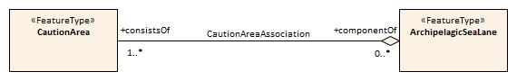

Figure 4-1 – Feature association

#### Aggregation

An aggregation is a relationship between two or more feature types where the aggregation is made up of component features.

EXAMPLE: An **Island Group** feature may be composed of multiple **Land Area** features to indicate the name of a group of islands.

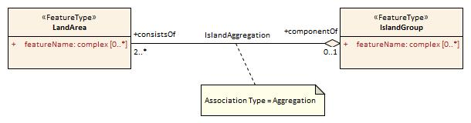

Figure 4-2 – Aggregation

#### Composition

A composition is a strong aggregation. In a composition, if a container feature is deleted then all of its containee features are deleted as well.

EXAMPLE: If a feature type that is considered a structure feature, such as a beacon, is deleted, then all of its component feature types that make up the equipment composition, such as lights and fog signals must be deleted as they make up the **Structure/Equipment** Composition.

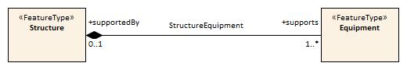

Figure 4-3 – Composition

### Information types

Details of information types can be found in Annex A – *Data Classification and Encoding Guide*, clauses 2.3, 2.4.7 and Section 24.

#### Spatial quality

Spatial quality attributes are carried in an information class called **Spatial Quality**. Details of spatial quality can be found in Annex A – *Data Classification and Encoding Guide*, clauses 2.4.7 and 24.5.

### Information relationships

An information relationship links instances of an information type with instances of a feature type, spatial object, or information type. Just as with feature relationships, the relationship may take the form of an association, aggregation, or composition.

#### Information association

An information association is used to describe a relationship between a feature type, spatial object, or information type on one side and an information type on the other side.

EXAMPLE: A **Nautical Information** information type provides additional information to any geo feature using an information association called **additional information**.

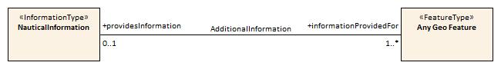

Figure 4-4 – Information association

#### Spatial associations

The information association “Spatial association” provides the binding between spatial objects and spatial quality. It is noted here because the S-100 Feature Catalogue model is incapable of describing this relationship.

Any spatial type other than surface may be associated with spatial quality (no use case for associating surfaces with spatial quality attributes has been identified). Vertical uncertainty is prohibited for curves as this dimension is not supported by curves.

### Attributes

S-101 defines attributes as either simple or complex.

#### Simple attributes

S-101 uses seven types of simple attributes; these types are listed in Annex A – *Data Classification and Encoding Guide*, clause 2.4.2. Descriptions of the simple attributes included in S-101 can be found in Annex A, Sections 27, 28 and 30.

#### Complex attributes

Complex attributes are aggregations of other attributes that are either simple or complex. The aggregation is defined by means of attribute bindings. Examples of modelling complex attributes can be found in S-100 Part 2a, Appendix 2a-A. Descriptions of the complex attributes included in S-101 can be found in Annex A – *Data Classification and Encoding Guide*, Section 29.

## Feature Object Identifier

Each real world feature within an ENC must have a unique universal Feature Object Identifier. This identifier is formed by the binary concatenation of the contents of the subfields of the “Feature Object Identifier” [FOID] field. Information types must not have a FOID.

The FOID may be used to identify that the same feature has instances in separate datasets. For example, the same feature included in different maximum display scale datasets or a feature being split by the ENC dataset limits within the same maximum display scale.

FOIDs must not be repeated in a dataset. Where a real-world feature has multiple parts within a single ENC dataset due to ENC dataset limit truncations, the feature will reference each spatial part of the feature within the dataset. This is accomplished in the ISO/IEC 8211 encoding by including a Spatial Association for each disjoint component. When a feature’s geometry is split each component must be represented by a separate spatial feature that the feature refers to.

Where a real-world feature is repeated in multiple datasets of different maximum display scale, the FOID should be repeated for each instance of the feature. Where this occurs, all instances of the geo feature must be identical, that is same feature class and attribute values.

## Dataset

### Introduction

A dataset is a grouping of features, attributes, geometry and metadata which comprises a specific coverage.

### Dataset rules

In order to facilitate the efficient processing of ENC data the geographic coverage of a given **maximum display scale** may be split into multiple datasets (see clause 4.5.4).

The discovery metadata of a dataset must list all the **Data Coverage** features contained within that dataset and their assigned scale attributions.

An ENC update dataset must not change the limit of a **Data Coverage** feature for the base ENC dataset. Where the limit of a **Data Coverage** feature for a base ENC dataset is to be changed, this must be done by issuing a New Edition of the dataset.

A dataset must not cross the 180° meridian.

### Data Coverage rules

* All base datasets (new dataset, new edition and re-issue) must contain at least one **Data Coverage** feature.
* The data boundary of the base dataset is defined by the extent of the **Data Coverage** features and must be contained within the bounding box.
* **Data Coverage** features from different datasets covering the same geographical area must have non-overlapping display scale ranges (see clause 4.6). The scale ranges should, as much as possible, be continuous.

[Exception: At areas of agreed national data limits, where, if it is difficult to achieve a perfect join, an overlapping buffer zone of up to 5 metres may be used. For this situation, there must be no gaps in data between the adjoining datasets.]

Data Producers should develop consistent S-101 ENC schemes carefully and try to avoid complex situations, using a regional approach where possible.

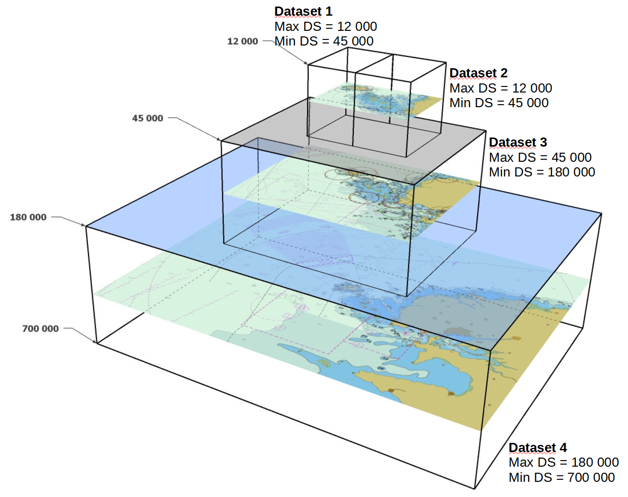

Figure 4-5 – Example of Datasets with single Data Coverage feature

* When a dataset has multiple **Data Coverage** features:
  1. The **minimum display scale**s must all be the same; and
  2. The **maximum display scale**s may be different.
* When a dataset has multiple **Data Coverage** features then the **maximum display scale** of the dataset must be equal to the largest **maximum display scale** of the **Data Coverage** features.

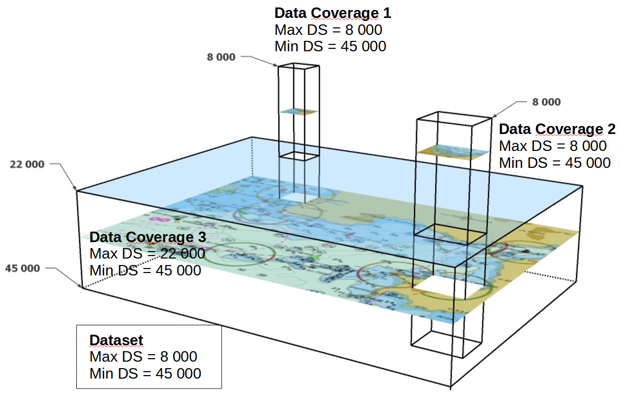

Figure 4-6 – Dataset with multiple Data Coverage features

### Dataset size

#### Datasets must not exceed 10 MB.

Update datasets should not normally be larger than 50 kb and must not be larger than 200 kb.

## Display scale range

A scale range of a dataset is used to indicate a range of scales between which a producer considers the data is intended for use. (See clause 4.7 for how datasets are to be loaded and unloaded within a navigation system.) The smallest scale is defined by the **minimum display scale** and the largest scale by the **maximum display scale**. These scales must be set at one of the scales specified in clause 3 (spatial resolutions).

There must not be overlapping scale ranges between datasets covering the same geographical area.

When the mariner’s selected viewing scale (MSVS) is smaller than the value indicated by **minimum display scale**, features within the **Data Coverage** feature are not displayed, except where the System Database does not contain a dataset covering the area at a smaller scale, in which case the dataset will be continuously displayed.

When the MSVS is larger than the value indicated by **maximum display scale**, the overscale indication, in the form of an overscale factor and pattern covering the area that is overscale, must be shown. When at own ship’s position a dataset with a larger **maximum display scale** than the MSVS is available, an indication is required and must be shown on the same screen as the chart display.

Within ENC schemes it is preferable that the scale ranges for different datasets covering the same geographical area to be continuous (see clause 4.5.3). However, where the scale ranges are non-continuous, the ECDIS will display the larger scale dataset until the MSVS is equal to or at smaller scale than the **maximum display scale** of the next smaller scale dataset**.**

## Dataset loading and display order

A new algorithm for dataset loading and unloading within a navigation system is prescribed in S-101 in order for the appropriate ENC to be viewed at the mariner’s selected viewing scale. This will simplify the process for navigation systems, giving clear and concise rules on how and when data is loaded and unloaded. The concept of navigation purpose is restricted for use in presenting ENCs in a visual catalogue and must not be used for determining which dataset should be displayed.

Details of the dataset loading and data display algorithms are available in Annex D – *Dataset Loading Algorithm (Dataset Selection)*.

Note 1: The algorithms only address loading and display related to visualization within the system graphics window. The application may need to load other datasets to satisfy requirements related to alerts processing, such as MSC.232(82) A11.2.

Note 2: Light sectors. It should be possible, on request, for the mariner to be capable of identifying the colour of the sectors affecting the ship, even if the lights involved are off the display.

### Dataset loading algorithm (dataset selection)

See Annex D – *Dataset Loading Algorithm (Dataset Selection)*.

### Dataset display order (dataset rendering)

To assist implementers, an algorithm describing how the selected datasets must be drawn will be prepared for S-101 Edition 1.2.0.

Figures 4-7 to 4-9 below are intended to assist in understanding how the datasets should be displayed in the system graphics window:

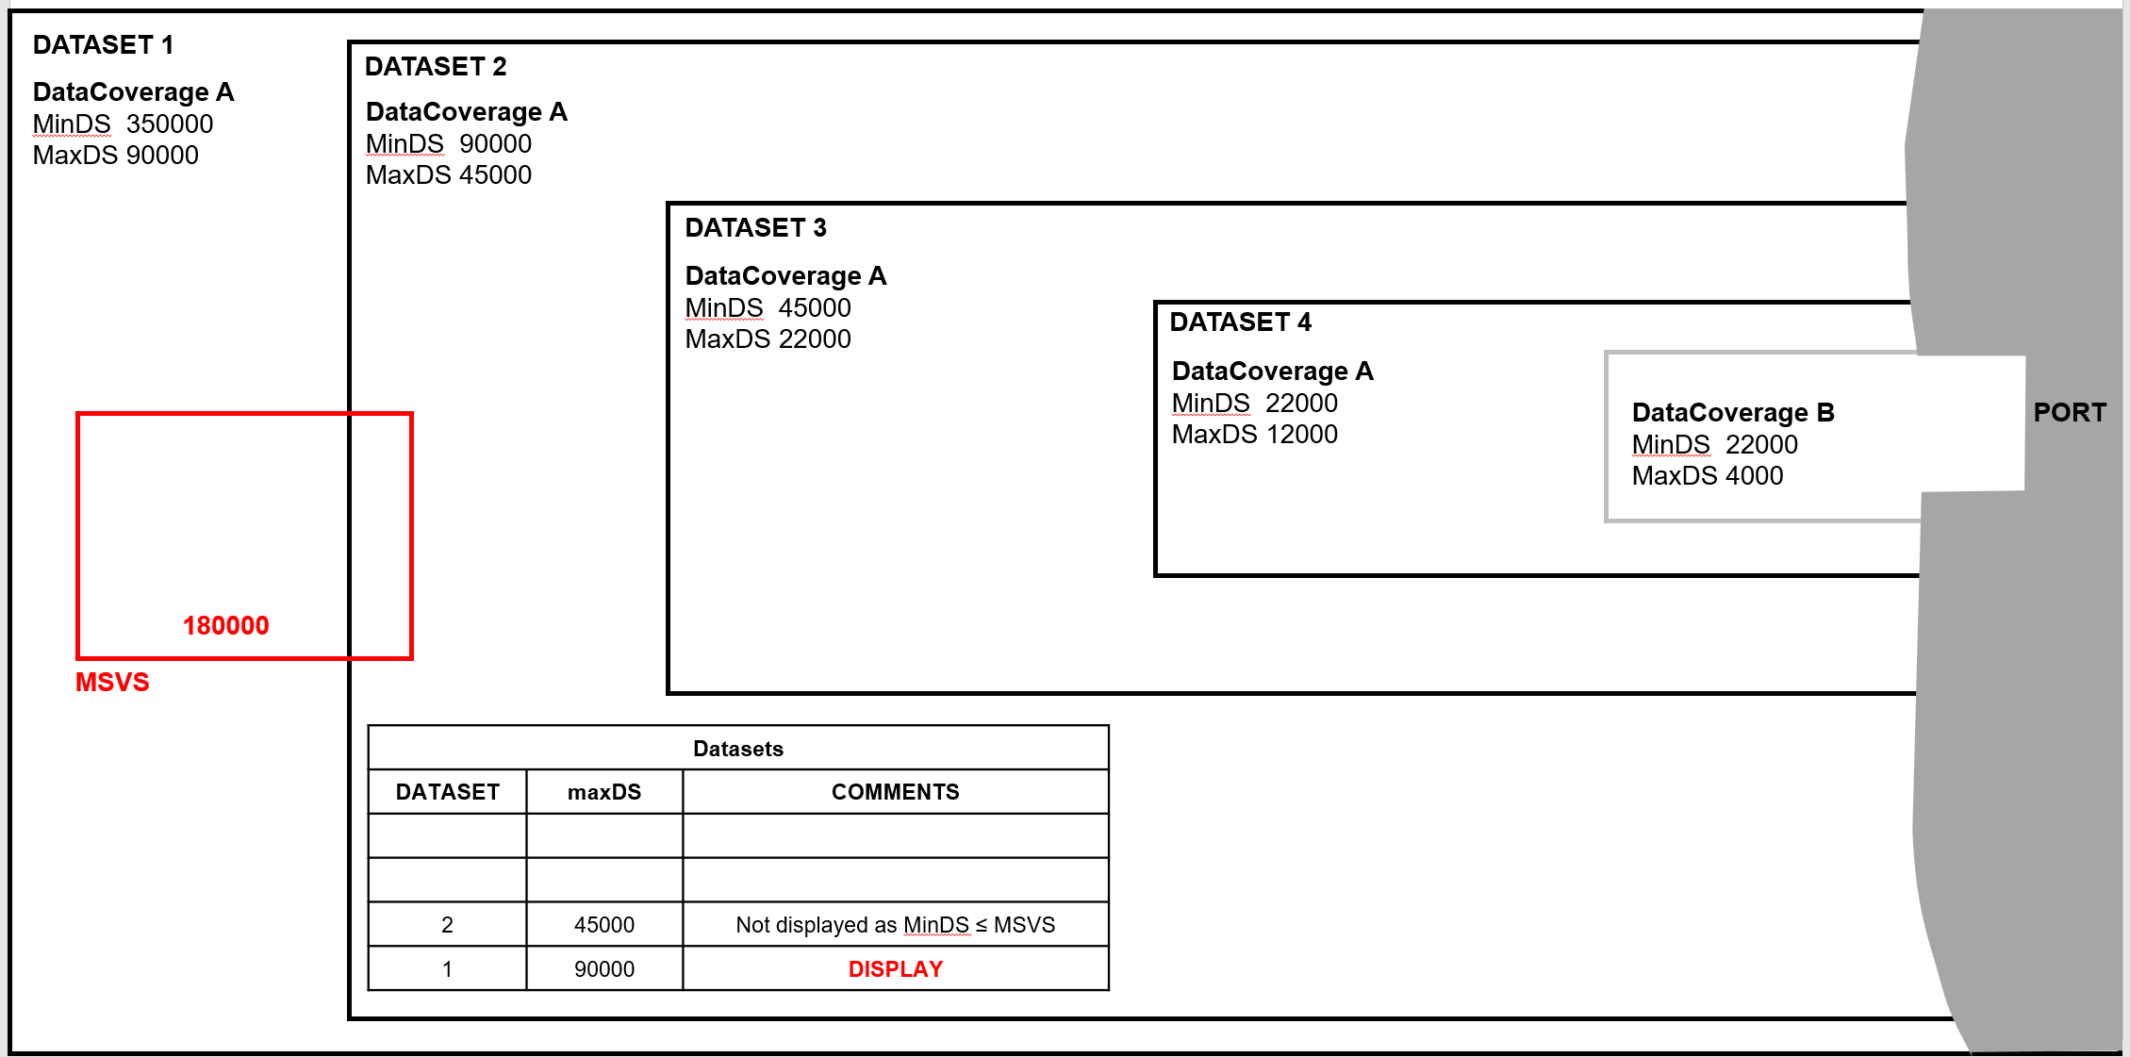

Figure 4-7 – Dataset loading – scenario 1

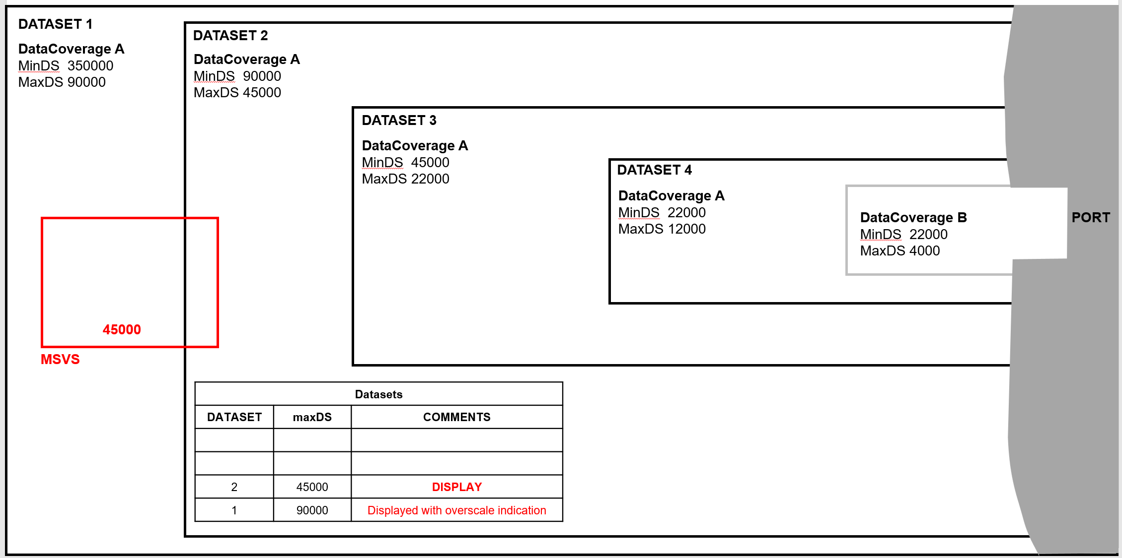

Figure 4-8 – Dataset loading – scenario 2

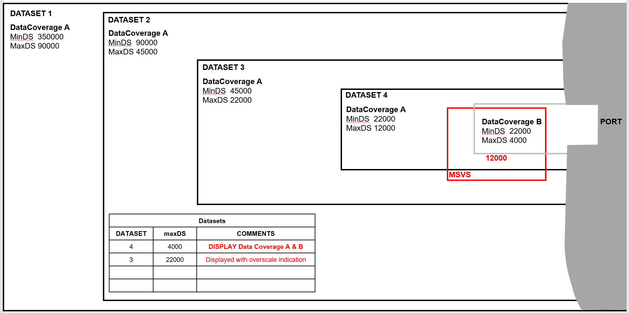

**Figure 4-9 – Dataset loading – scenario 3**

## Geometry

### S-100 level 3a geometry

The underlying geometry of an ENC is constrained to level 3a which supports 0, 1 and 2 dimensional features (points, curves and surfaces) as defined by S-100 Part 7 – *Spatial Schema*.

Level 3a is described by the following constraints:

* Each curve must reference a start and end point (they may be the same).
* Curves must not self intersect. See Figure 4-11.
* Areas are represented by a closed loop of curves beginning and ending at a common point.
* In the case of areas with holes, all internal boundaries must be completely contained within the external boundary and the internal boundaries must not intersect each other or the external boundary. Internal boundaries may touch other internal boundaries or the external boundary tangentially (that is at one point) as shown in Figure 4-12.
* The outer boundary of a surface must be in a clockwise direction (surface to the right of the curve) and the curve orientation positive. The inner boundary of a surface must be in a counter-clockwise direction (surface to the right of the curve) and the curve orientation negative. See Figure 4-13.

S-101 further constrains Level 3a with the following:

* Coincident linear geometry must be avoided when there is a dependency between features.
* The interpolation of GM_CurveSegment must be loxodromic.
* Linear geometry is defined by curves which are made of curve segments. Each curve segment contains the geographic coordinates as control points and defines an interpolation method between them. The distance between two consecutive control points must not be less than 0.3 mm at the maximum display scale of the data.

The following exception applies to S-101:

* The use of coordinates is restricted to two dimensions, except in the case of features encoded using GM_Point (point) and GM_Multipoint (pointSet) which may have three dimensional coordinates.

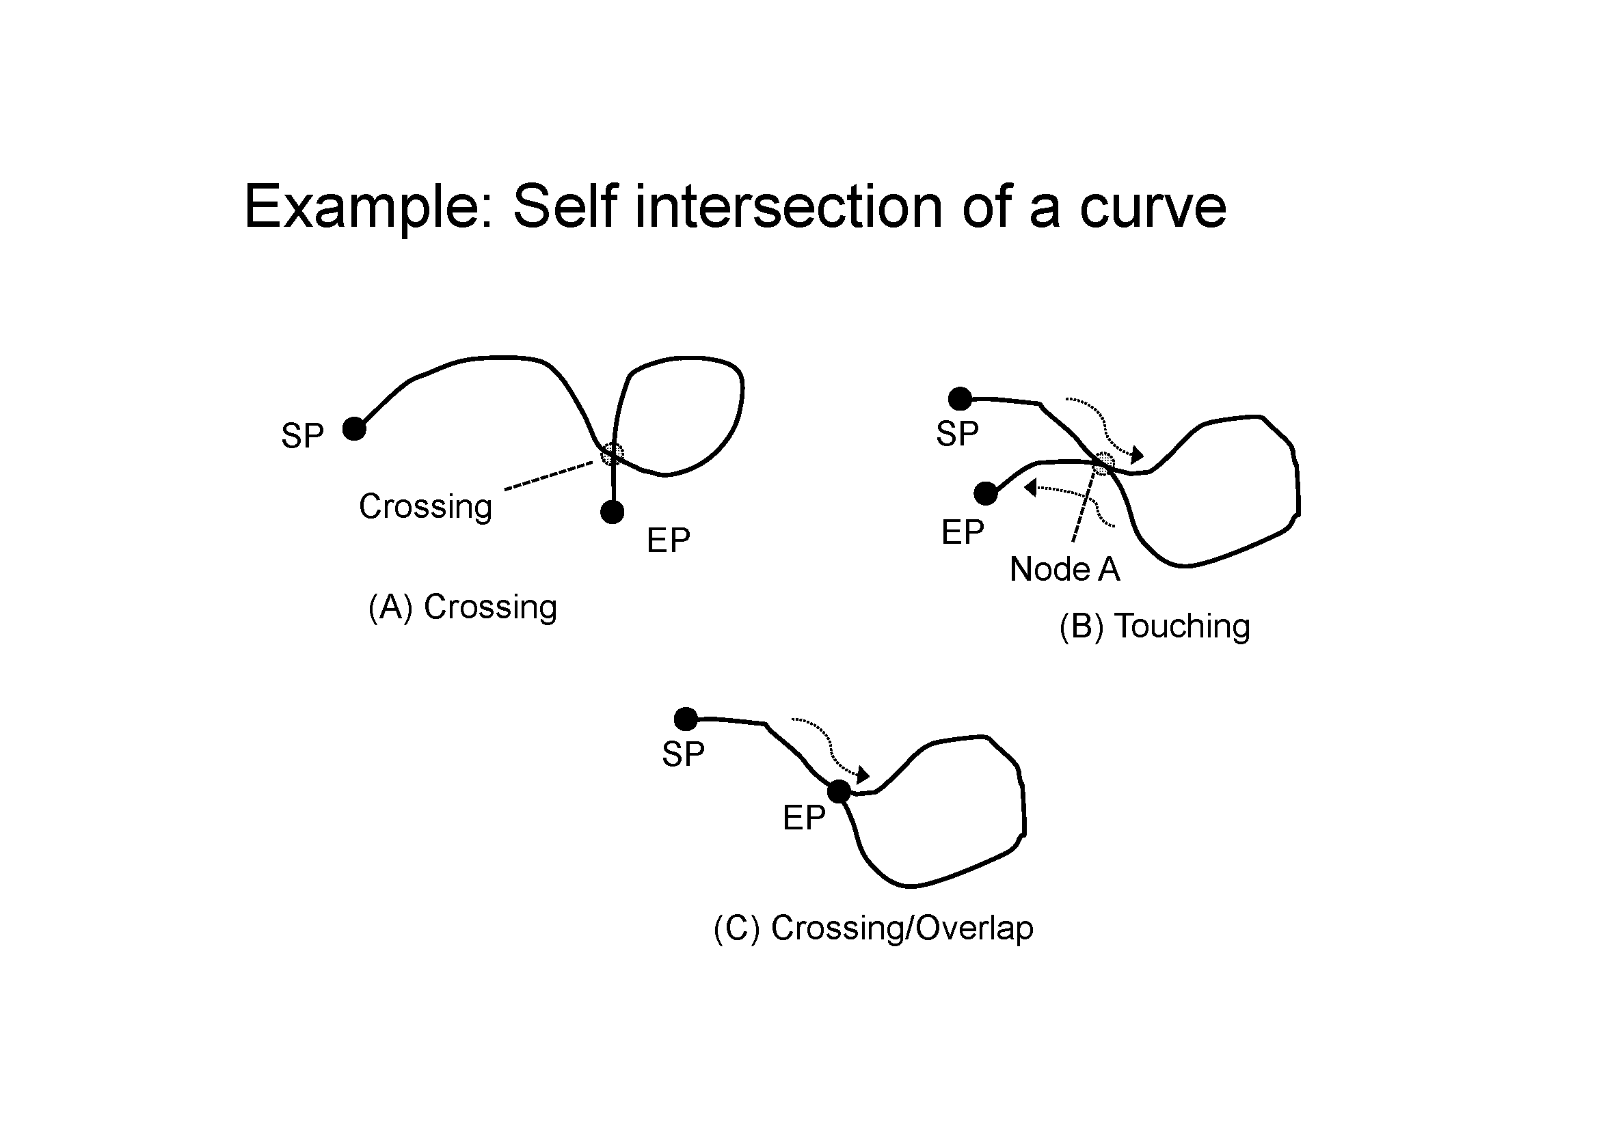

Figure 4-11 – Self intersect example

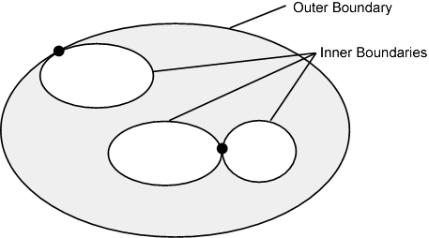

Figure 4-12 – Area Holes

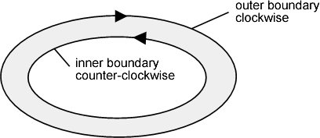

Figure 4-13 – Boundary direction

### Masking

In certain circumstances, the symbolisation of a curve may need to be suppressed. This is done using the Masked Spatial Type [MASK] field of the Feature Type record. The Mask Update Instruction [MUIN] must be set to {1} and Referenced Record Name [RRNM] and Referenced Record Identifier [RRID] fields must be populated with the values of the referenced spatial record. The Mask Indicator [MIND] subfield must be set to either {1} or {2} (see Annex B – clause B-5.1.33).

Figure 4-14 is an example without masking and Figure 4-15 is an example of a masked edge between **River** and **Depth Area** features, where the seaward edge of the **River** should be masked. In this example MIND is set to {2} – suppress portrayal.

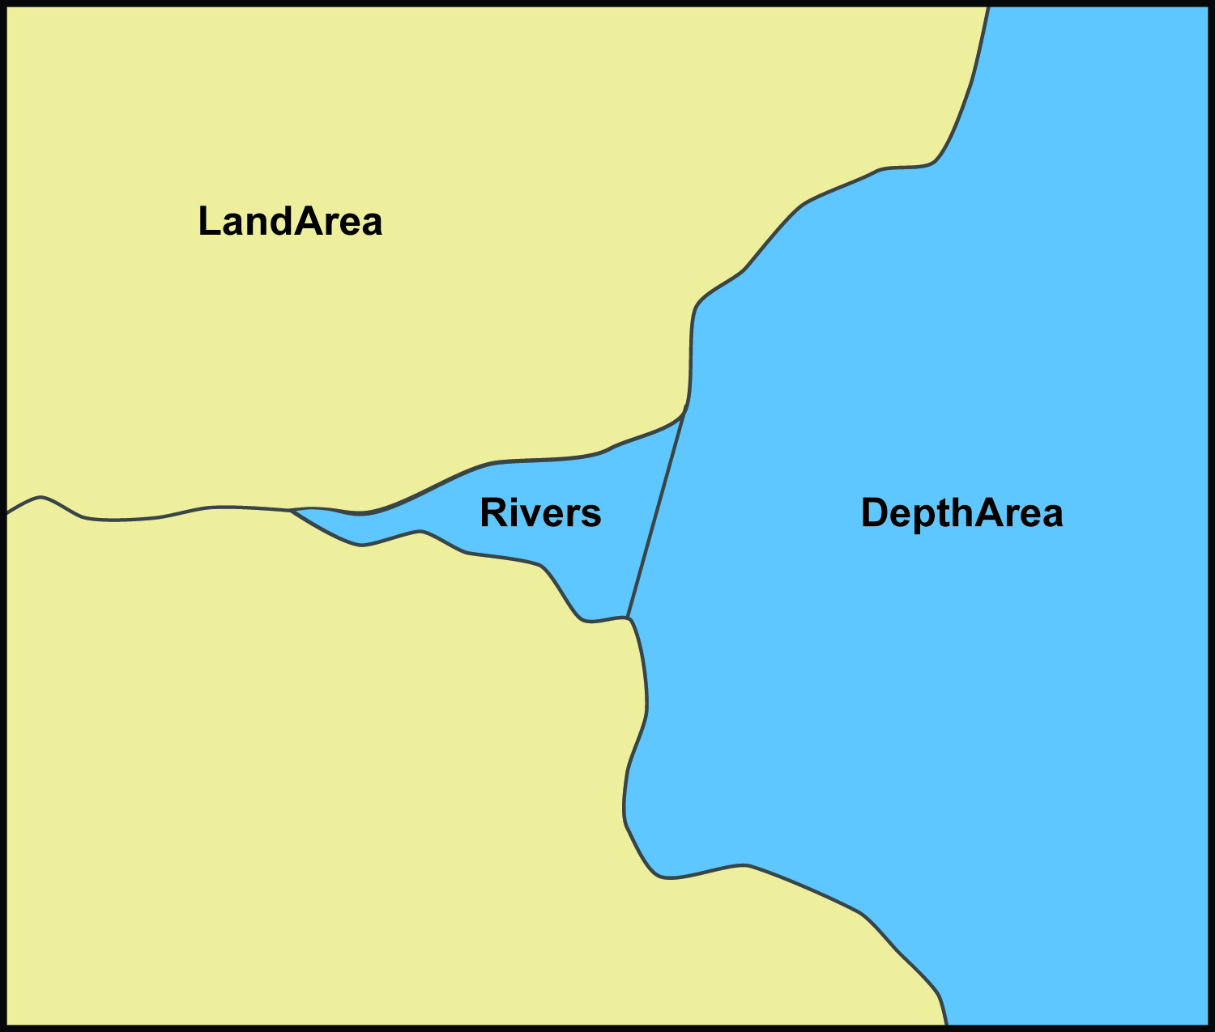

Figure 4-14 – Example without masking

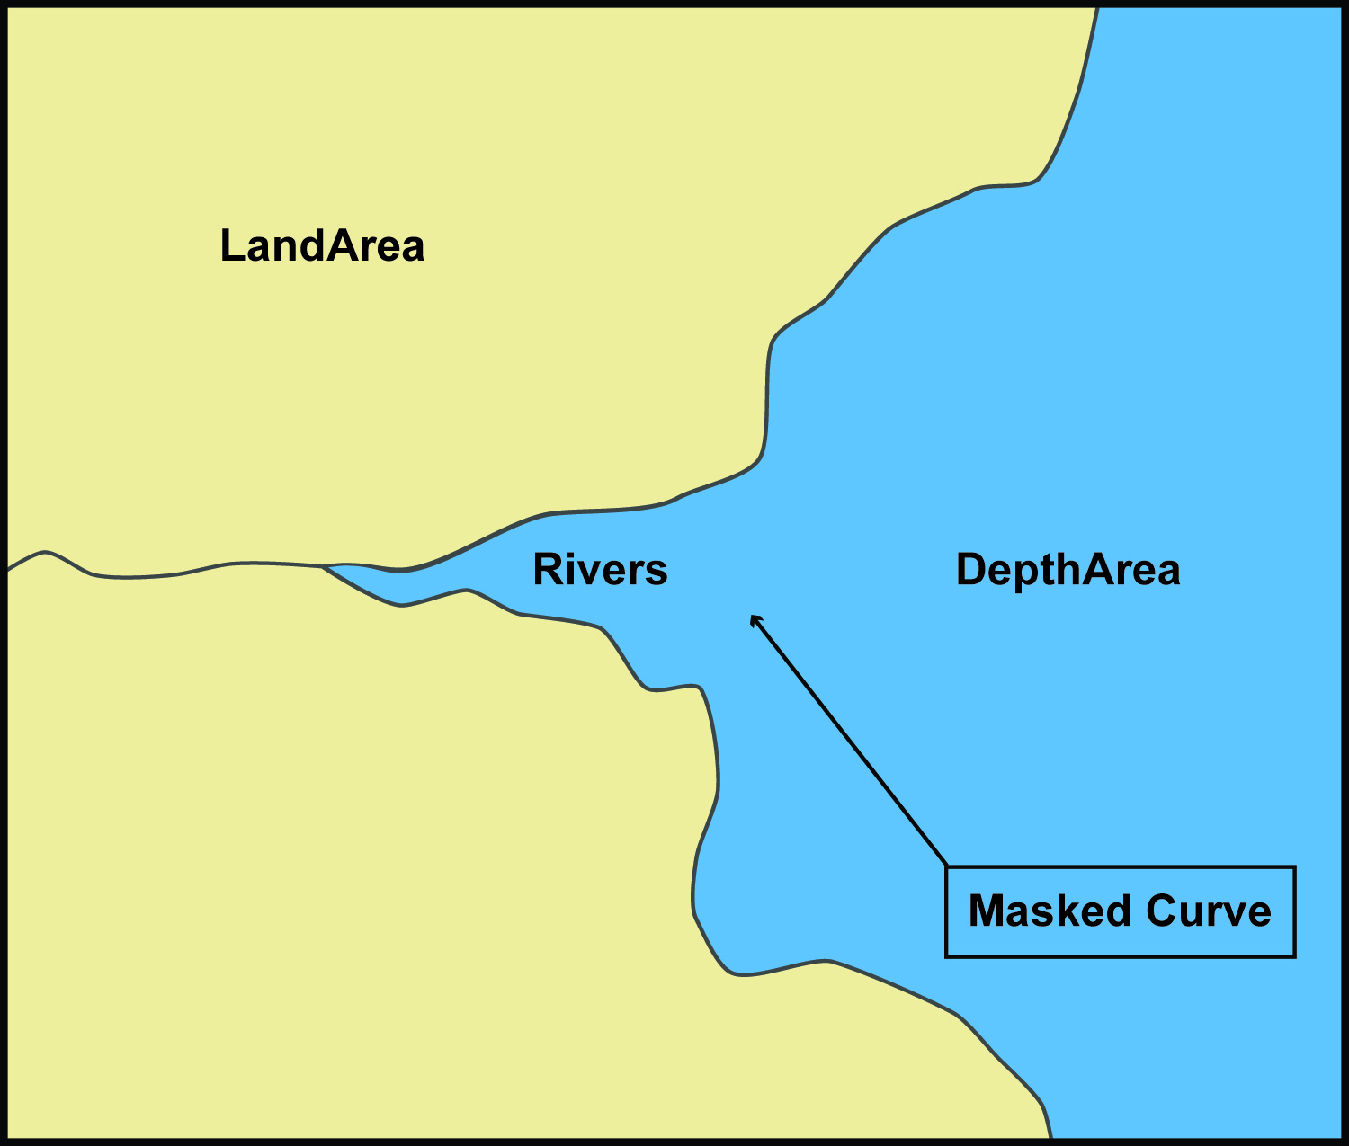

Figure 4-15 – Example with masking

# Coordinate Reference Systems (CRS)

## Introduction

An ENC dataset must define at least one compound CRS, which must be composed of one geodetic CRS and one vertical CRS. All compound CRSs within the same dataset must use the same geodetic CRS.

## Horizontal Coordinate Reference System

For ENC the horizontal CRS must be EPSG:4326 (WGS84). The full reference to EPSG:4326 can be found at [www.epsg-registry.org](http://www.epsg-registry.org).

**Horizontal Coordinate Reference System:** EPSG:4326 (WGS84)

**Projection:** None

**Temporal reference system:** Gregorian calendar

**Coordinate Reference System registry:** [EPSG Geodetic Parameter Registry](http://www.epsg-registry.org/)

**Date type (according to ISO 19115):** 002- publication

**Responsible party:** International Organisation of Oil and Gas Producers (IOGP)

**URL:** <http://www.iogp.org>

## Vertical CRS for Soundings

For ENC the vertical CRS must be in metres. Depths are represented by positive values, while negative values indicate intertidal (drying) soundings.

Although all coordinates in a dataset must refer to the same geodetic CRS, different Vertical Datums can be used for the depth component of a coordinate tuple. Therefore the vertical CRS can be repeated. For each vertical CRS a unique identifier is defined. Those identifiers will be used to indicate which Vertical CRS is used.

The encoding for the Coordinate Reference System record fields can be found at Annex B, clauses B-5.1.9 to B-5.1.12; and is demonstrated with the following examples. The example at Table 5-1 specifies a compound CRS. The first component is a 2D Geographic CRS (WGS84). The second component is a Vertical CRS for depth using the Vertical Datum: Lowest Astronomical Tide.

Table 5-1 – Compound CRS (WGS84 and Lowest Astronomical Tide)

|  |  |  |  |
| --- | --- | --- | --- |
| **Field** | **Subfield** | **Value** | **Description** |
| **CSID** |  |  | **Coordinate Reference System Record Identifier** |
|  | RCNM | 15 | Record Name (15 = Coordinate Reference System Identifier) |
|  | RCID | 1 | Record Identification Number |
|  | NCRC | 2 | Number of CRS Components |
| **CRSH** |  |  | **Coordinate Reference System Header** |
|  | CRIX | 1 | CRS Index |
|  | CRST | 1 | CRS Type (1 = 2D Geographic) |
|  | CSTY | 1 | Coordinate System Type (1 = Ellipsoidal CS) |
|  | CRNM | WGS84 | CRS Name |
|  | CRSI | 4326 | CRS Identifier |
|  | CRSS | 2 | CRS Source (2 = EPSG) |
|  | SCRI |  | CRS Source Information (omitted) |
| **CRSH** |  |  | **Coordinate Reference System Header** |
|  | CRIX | 2 | CRS Index |
|  | CRST | 5 | CRS Type (5 = Vertical) |
|  | CSTY | 3 | Coordinate System Type (3 = Vertical) |
|  | CRNM | Depth - lowest astronomical tide | CRS Name |
|  | CRSI |  | CRS Identifier (omitted) |
|  | CRSS | 255 | CRS Source (255 = Not Applicable) |
|  | SCRI |  | CRS Source Information (omitted) |
| **CSAX** |  |  | **Coordinate System Axes** |
|  | AXTY | 12 | Axis Type (12 = Gravity Related Depth) |
|  | AXUM | 4 | Axis Unit of Measure (4 = Metres) |
| **VDAT** |  |  | **Vertical Datum** |
|  | DTNM | lowest astronomical tide | Datum Name |
|  | DTID | 23 | Datum Identifier (23 = Lowest Astronomical Tide) |
|  | DTSR | 2 | Datum Source (2 = Feature Catalogue) |
|  | SCRI |  | Datum Source Information (omitted) |

The example at Table 5-2 is similar to the above except that its second component is encoded with the Vertical Datum: Mean Sea Level.

Table 5-2 – Compound CRS (WGS84 and Mean Sea Level)

|  |  |  |  |
| --- | --- | --- | --- |
| **Field** | **Subfield** | **Value** | **Description** |
| **CSID** |  |  | **Coordinate Reference System Record Identifier** |
|  | RCNM | 15 | Record Name (15 = Coordinate Reference System Identifier) |
|  | RCID | 1 | Record Identification Number |
|  | NCRC | 2 | Number of CRS Components |
| **CRSH** |  |  | **Coordinate Reference System Header** |
|  | CRIX | 1 | CRS Index |
|  | CRST | 1 | CRS Type (1 = 2D Geographic) |
|  | CSTY | 1 | Coordinate System Type (1 = Ellipsoidal CS) |
|  | CRNM | WGS84 | CRS Name |
|  | CRSI | 4326 | CRS Identifier |
|  | CRSS | 2 | CRS Source (2 = EPSG) |
|  | SCRI |  | CRS Source Information (omitted) |
| **CRSH** |  |  | **Coordinate Reference System Header** |
|  | CRIX | 2 | CRS Index |
|  | CRST | 5 | CRS Type (5 = Vertical) |
|  | CSTY | 3 | Coordinate System Type (3 = Vertical) |
|  | CRNM | Depth - mean sea level | CRS Name |
|  | CRSI |  | CRS Identifier (omitted) |
|  | CRSS | 255 | CRS Source (255 = Not Applicable) |
|  | SCRI |  | CRS Source Information (omitted) |
| **CSAX** |  |  | **Coordinate System Axes** |
|  | AXTY | 12 | Axis Type (12 = Gravity Related Depth) |
|  | AXUM | 4 | Axis Unit of Measure (4 = Metres) |
| **VDAT** |  |  | **Vertical Datum** |
|  | DTNM | mean sea level | Datum Name |
|  | DTID | 3 | Datum Identifier (3 = Mean Sea Level) |
|  | DTSR | 2 | Datum Source (2 = Feature Catalogue) |
|  | SCRI |  | Datum Source Information (omitted) |

# Data Quality

## Introduction

Data quality allows users and user systems to assess fitness for use of the provided data. Data quality measures and the associated evaluation are reported as metadata of a data product. This metadata improves interoperability with other data products and provides scope for usage by user groups that the data product was not originally intended for. The secondary users can make assessments of the data product usefulness in their application based on the reported data quality measures.

For S-101 the following data quality elements have been included:

* Conformance to this Product Specification;
* Intended purpose of the data product;
* Completeness of the data product in terms of coverage;
* Logical consistency;
* Depth uncertainty and accuracy;
* Positional uncertainty and accuracy;
* Thematic accuracy;
* Temporal quality;
* Aggregation measures;
* Validation checks or conformance checks including:
* General tests for dataset integrity; and
* Specific tests for compliance against the S-101 data model.

For S-101 data quality is divided into two parts – data compliance, usability and integrity against all requirements of S-101; and bathymetric data quality.

### Data compliance and usability

All S-101 datasets must be validated against the above data quality elements using conformance checks that are located in Annex C – *ENC Validation Checks*. As a minimum requirement, all datasets must conform to all checks that are categorized as “Critical” in Annex C.

S-101 datasets must conform to all mandatory elements of Annex A – *Data Classification and Encoding Guide*, where the word ‘must’ is used.

In addition to the above, dataset usability must be assessed against:

* Intended user requirements in regard to coverage, scale and specific content requirements as defined by the Producing Agency and key stakeholders;
* Conformance to established maintenance processes (see Section 8); and
* Overall compliance with the S-101 Product Specification, including context-specific evaluation of individual encoding instances for requirement of conformance to checks classified as “Error” and “Warning” in Annex C – *ENC Validation Checks*.

For dataset integrity requirements, see clause 11.6.

# Data Capture and Classification

The S-101 ENC Data Classification and Encoding Guide (DCEG) describes how data describing the real world should be captured using the types defined in the S-101 Feature Catalogue. This Guide is located at Annex A.

# Maintenance

## Introduction

This clause describes the requirement to adequately maintain datasets; use of newly acquired source data; maintenance requirements within the overall production process; and how Feature and Portrayal Catalogues are to be managed within an S-100 based marine navigation system.

## Maintenance and update frequency

Datasets must be maintained as needed; and the overall production process must include mechanisms for ENC updating designed to meet the needs of the mariner regarding safety of navigation.

## Data source

Data Producers must use all available and applicable sources, as evaluated against a robust data assessment process, to maintain and update ENC datasets as required.

## Production process

Data Producers should follow their established production processes for maintaining and updating datasets. Data must be maintained against S-101 Annex A – *Data Classification and Encoding Guide*, checked against S-101 Annex C – *ENC Validation Checks*, and encapsulated in ISO/IEC 8211.

Only maintained datasets that conform to the mandatory requirements outlined in S-101 will be considered to be an ENC satisfying the SOLAS chart carriage requirements for use in an ECDIS.

## Feature and Portrayal Catalogue management

For each new version of the S-101 Product Specification a new Feature and/or Portrayal Catalogue may be released. The management of Feature and Portrayal Catalogues in end user systems is described in IHO Publication S-98 – *Data Product Interoperability in S-100 Navigation Systems*.

# Portrayal

## Introduction

S-101 portrayal is intended to contribute to the safe operation of an S-100 based marine navigation system by:

* Ensuring base and supplementary levels of display for ENC data; standards of symbols, colours and their standardized assignment to features; scale limitations of data presentation; and appropriate compatibility with paper chart symbols as standardized in the Chart Specifications of the IHO (IHO Publication S-4);
* Ensuring the display is clear and unambiguous;
* Establishing an accepted pattern for presentation that becomes familiar to mariners and so can be recognized instantly without confusion; and
* Utilizing the S-100 portrayal model to ensure interoperability.

S-101 portrayal is covered by the portrayal model as defined in S-100. This model reflects how the Portrayal Catalogue is defined for use in marine navigation systems. The Portrayal Catalogue defines symbology and the portrayal rules for each feature/attribute combination contained in the Feature Catalogue.

S-101 uses the portrayal process defined in S-100 Part 9A.

## Portrayal Catalogue

Citation information for the Portrayal Catalogue is provided in Table 9-1 below.

Table 9-1 – S-101 Portrayal Catalogue

|  |  |  |  |
| --- | --- | --- | --- |
| **No.** | **ISO class or attribute** | **Type** | **Value** |
| -- | CI_Citation | Class | -- |
| 1 | title | CharacterString | S-101 Portrayal Catalogue |
| 2 | date | CI_Date (class) | -- |
| 2.1 | date | DateTime | 2022-xx-xxT00:00:00 |
| 2.2 | dateType | CI_DateTypeCode (ISO codelist) | publication |
| 3 | edition | CharacterString | 1.1.0 |
| 4 | editionDate | DateTime | 2022-xx-xxT00:00:00 |
| 5 | citedResponsibleParty | CI_Responsibility (class) | -- |
| 5.1 | role | CI_RoleCode (ISO codelist) | publisher |
| 5.2 | party | CI_Organisation (class) | -- |
| 5.2.1 | name | CharacterString | International Hydrographic Organization |
| 6 | otherCitationDetails | CharacterString | (Replace with website navigation instructions, etc.. ISO 19115-1 defines this attribute as “other information required to complete the citation that is not recorded elsewhere.”) |
| 7 | onlineResource | CI_OnlineResource (class) | -- |
| 7.1 | linkage | CharacterString (URL) | <https://registry.iho.int/> |
| 7.2 | name | CharacterString | S-101 Portrayal Catalogue |
| 7.3 | description | CharacterString | XML Portrayal Catalogue accompanied by related files for symbols, colour profiles, rules, etc |

The Portrayal Catalogue contains the mechanisms for the system to portray information found in S-101 ENCs. The S-101 Portrayal Catalogue contains the following types of mechanisms and structures:

* Set of portrayal rules;
* Set of pixmaps, symbols, complex line styles, area fills, fonts and colour profiles.

The Portrayal Catalogue model is defined in S-100 Part 9, clause 9-13.

The S-101 Portrayal Catalogue is available in an XML document which conforms to the S-100 XML Portrayal Catalogue Schema. The structure for the Portrayal Catalogue is described in S-100 Part 9, clause 9-13.2.

# Data Product Format (Encoding)

## Introduction

This clause specifies the encoding for S-101 datasets. See Annex B for a complete description of the data records, fields and subfields defined in the encoding.

**Format Name:** ISO/IEC 8211

**Character Set:** ISO 10646 Base Multilingual Plane

**Specification:** S-100 profile of ISO/IEC 8211 (S-100 Part 10A)

### Encoding of latitude and longitude

Coordinates are stored as integers. Latitude and longitude are converted to integers using a multiplication factor held in the Dataset Structure Information field under [CMFX] and [CMFY] (see Annex B – clause B-5.1.2).

These coordinate multiplication factors must be set to {10000000} (107) for all datasets.

EXAMPLE: A longitude = 42.0000 is converted into X = longitude * CMFX = 42.0000 * 10000000 = 420000000.

### Encoding of depths as coordinates

Depths are converted from decimal metres to integers by means of the [CMFZ] (see Annex B – clause B-5.1.2). This Product Specification limits the resolution to one decimal place and therefore the [CMFZ] must be set to {10}.

EXAMPLE: A depth = 4.2 is converted in Z = depth*CMFZ = 4.2*10 = 42

Note: This does not apply to depth encoded as attributes.

### Numeric attribute encoding

Floating point and integer attribute values must not contain leading zeros. Floating point attribute values must not contain non-significant trailing zeros.

### Text attribute values

Character strings must be encoded using the character set defined in ISO 10646-1, in Unicode Transformation Format-8 (UTF-8).

### Unknown attribute values

In a Base dataset, when an attribute code is present, but the attribute value is missing, it means that the producer wishes to indicate that this attribute value is unknown.

In an Update dataset, when an attribute code is present, but the attribute value is missing it means:

• that the value of this attribute is to be replaced by an empty (null) value if it was present in the original dataset; or

• that an empty (null) value is to be inserted if the attribute was not present in the original dataset.

# Data Product Delivery

## Introduction

This clause specifies the encoding and delivery mechanisms for an S-101 ENC. Data which conforms to this Product Specification must be delivered by means of an Exchange Set.

The S-100 Exchange Set structure is described in S-100 Part 17, clause 17-4.1.

## Exchange Set

S-101 datasets are grouped into Exchange Sets. Each Exchange Set consists of one or more ENC datasets with a single Exchange Catalogue XML file containing metadata. Optionally, an associated XML Metadata file (S100_ResourcePurpose (ISOMetadata) – see S-100 Part 17, clause 17-4.5) may be included (see clause 11.5). It may also include one or more support files. The S-101 Exchange Set structure is the same as that described in S-100 Part 17, clause 17-4.1.

**Units of Delivery:**  Exchange Set

**Transfer Size:**  Unlimited

**Medium Name:**  Digital data delivery

**Other Delivery Information:**

Each Exchange Set has a single Exchange Catalogue which contains the discovery metadata for each dataset and references to any support files. See S-100 Part 17, clauses 17-4.4 and 17-4.5.

## Dataset

### Datasets

Four types of dataset files may be produced and contained within an Exchange Set:

* New dataset and New Edition of a dataset (Base dataset): Including new information which has not been previously distributed by updates. Each New Edition of a dataset must have the same name as the dataset that it replaces. A New Edition can also be ENC data that has previously been produced for this area and at the same maximum display scale. The encoding structure is located in Annex B – clause B-5.
* Update: Changing some information in an existing dataset. Each Update dataset file must have the same name as the original base cell file, with an extension number greater than or equal to 001 (see EEE in clause 11.3.2 below). They must not extend the geographical area covered by the base cell file to which they apply (see clause 4.5.2)*.* The encoding structure for an Update is located in Annex B – clause B-6.
* Re-issue of a dataset: Including all the updates applied to the original dataset up to the date of the reissue. A Re-issue is intended to avoid unnecessary loading of the Base cell and all applicable updates individually for new users of the dataset, therefore does not contain any new information additional to that previously issued by updates, and can be issued at any time. The encoding structure is located in Annex B – clause B-5.
* Cancellation: The dataset is cancelled and is deleted from the system. The encoding structure for a Cancellation file is located in Annex B – clause B-7.

### Dataset file naming

101CCCCØØØØØØØØØØ.EEE

The file name forms a unique S-101 identifier where:

* 101 – the first 3 characters identify the dataset as an S-101 dataset (mandatory).
* CCCC – the fourth to seventh characters identify the Producer Code of the issuing agency (mandatory for S-101). Where the Producer Code is derived from a 2 or 3 character format (for instance when converting S-57 ENCs), the missing characters of the Producer Code may be populated with zeros (“00” or “0” respectively) for the sixth and seventh characters of the dataset file name, as required.
* ØØØØØØØØØØ – the eighth to the maximum seventeenth characters are optional and may be used in any way by the producer to provide the unique file name. The following characters are allowed in the dataset name: A to Z (upper case characters only), 0 to 9 and the special character _ (underscore). It is not required to use all the available characters, however at least one character must be used.
* .EEE – new datasets and New Editions use 000, updates start at 001 and increment until a limit of 999 (mandatory). Re-issues use the same number as the last Update applied to the dataset. Cancellations use the next sequential number from the previous Update applied to the dataset.

### New Editions, re-issues, updates and cancellations

This section defines the sequencing of S-101 datasets for New Editions, updates and re-issues. In order to ensure that feature type updates are incorporated into an end user system in the correct sequence without any omission, a number of parameters encoded in the data are used in the following way:

**Edition number** When a dataset is initially created (Base dataset), the Edition number 1 is assigned to it. The Edition number is increased by 1 at each New Edition.

**Update number** Update number 0 is assigned to a new dataset and a New Edition. The first update dataset file associated with this new dataset must have update number 1. The update number must be increased by one for each subsequent update, until a New Edition is released.

A re-issue of a dataset must have the update number of the last update applied to the dataset, and use the same Edition number.

**Issue date** Date up to which the Data Producer has incorporated all applicable changes. The issue date must be greater than the previous issue date of the dataset.

In order to cancel a dataset, an update dataset file is created for which the Edition number must be set to 0. This method is only used to cancel a Base dataset file. Where a dataset is cancelled and its name is reused at a later date, the issue date must be greater than the issue date of the cancelled dataset. When the dataset is cancelled it must be removed from the system.

An Exchange Set may contain Base dataset files and update dataset files for the same datasets. Under these circumstances the update dataset files must follow on in the correct sequential order from the last update applied to the Base dataset file.

## Support files

Dataset support files offer supplementary information that can be included in an ENC Exchange Set.

* Text files must contain only general text as defined by this standard (text consisting only of printable characters and without HTML, XML, or other markup). Extensible mark-up language (XML) supports UTF-8 character encoding. **(TXT)**, **(XML)**, **(HTM)**.
* Picture files must be in TIFF (6.0 specification) **(TIFF)**.

Table 11-1 – Support file extensions

|  |  |  |
| --- | --- | --- |
| **File Types** | **Extensions** | **Comment** |
| **Text** | TXT |  |
|  | HTM | HTML files must only include inline or embedded Cascading Style Sheet (CSS) information and must not contain embedded Javascript or other dynamic content, for example DHTML, Flash etc. |
|  | XML | XML documents must only be included in accordance with guidance provided within the Data Classification and Encoding Guide (S-101 Annex A). This may include a Schema for the validation of XML documents. |
| **Picture** | TIF | Baseline TIFF 6.0. |

### Support file Naming

All support files must have unique universal file identifiers. The file identifier of support information should not be used to describe the physical content of the file. The support file metadata that accompanies the file will inform the user of the name and purpose of the file (that is new, replacement and deletion).

In this encoding the support files are named according to the specifications given below:

101CCCCØØØØØØØØØØ.EEE

The main part forms an identifier where:

* 101 – the first 3 characters identify the support file as applicable to an S-101 dataset (mandatory).
* CCCC – the fourth to seventh characters identify the Producer Code of the issuing agency (mandatory). Where the Producer Code is derived from a 2 or 3 character format (for instance when converting S-57 ENCs), the missing characters of the Producer Code may be populated with zeros (“00” or “0” respectively) for the sixth and seventh characters of the support file name, as required.
* ØØØØØØØØØØ – the eighth to the maximum seventeenth characters are optional and can be used in any way by the Producer to provide the unique support file name. The following characters are allowed in the support file name: A to Z (upper case characters only), 0 to 9 and the special character _ (underscore). It is not required to use all the available characters, however at least one character must be used.
* .EEE – support file extension. (TXT, HTM, XML or TIF).

### Support file management

When a support file is created or a subsequent version is issued it must carry its own issue date and be supported with a digital signature which authenticates it against the Producer’s public key included in the Exchange Set metadata.

The type of support file is indicated in the “purpose” field of the discovery metadata. Three types: new, replacement and deletion are defined. Support files carrying the “deletion” flag must be removed from the system. When a feature pointing to a text, picture or application file is deleted or updated so that it no longer references the file, the system software must check to see whether any other feature references the same file, before that file is deleted.

Each support file required must be included only once in the Exchange Set.

Support files must be stored in a separate folder within the Exchange Set, refer to Figure 12-3 – S-101 Exchange Set.

Re-use of a support file name after a deletion period is possible only if the support file edition number is higher than the previous edition number before deletion.

Only the latest edition of a support file can be used. As soon as a New Edition is created and installed, the older version is retired and can no longer be used by any feature.

If a support file is associated with multiple features in one or several datasets, a New Edition of the file will immediately be used by all associated features.

If a New Edition of a support file contains changes not applicable to all previous associated features, a completely new file must be created instead. This is to maintain the support file information in the associated features not effected by the last changes. The associations to the old file must then be removed and new associations created for the new support file. Features where changes were not applicable will continue to use the old support file.

The following scenario demonstrates the rules related to versioning and issuing of new support files:

Figure 11-1: Three Caution areas are encoded within three different ENCs. All of them references the same support file A:

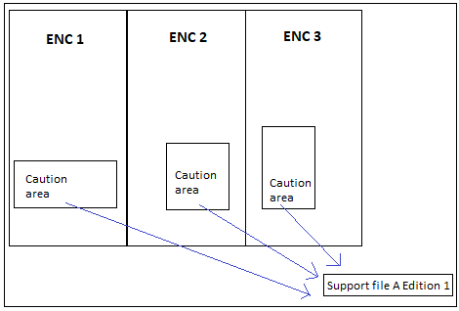

Figure 11-1 – Reference to new support file

Figure 11-2: Changes occur making it necessary to issue a New Edition of support file A. Edition 1 is no longer valid, and all 3 caution areas refer to the New Edition of support file A (Edition 1 of the support file is deleted from the system if referenced by no features):

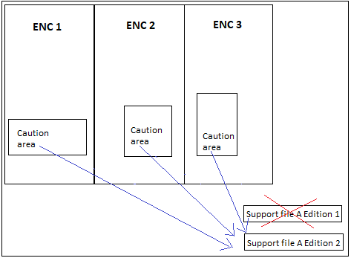

Figure 11-2 – Reference to New Edition of a support file

Figure 11-3: Changes occur that are only applicable to the Caution areas in ENC 1 and ENC 2. Consequently, these ENCs can no longer refer to support file A Edition 2:

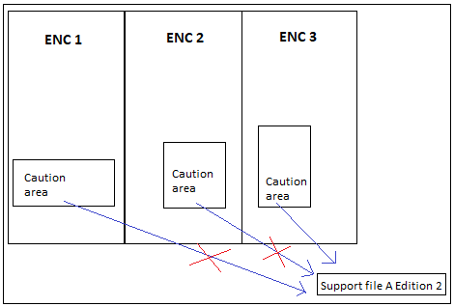

Figure 11-3 – Changes to support file affecting limited referenced features

Figure 11-4: A new support file B must be created for ENC 1 and ENC 2 to use as reference:

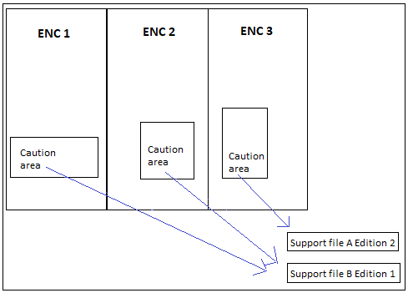

Figure 11-4 – New support file affecting limited referenced features

## Associated XML Metadata file

An associated XML Metadata file is expected to carry information specific to producing authorities’ internal production procedures, and is not intended for use within the end user systems.

If used, all associated XML Metadata files must have unique names. The name of the associated XML Metadata file should not be used to describe the physical content of the file.

The associated XML Metadata file must be named according to the specification given below:

MD_<data file base name>.XML

## S-101 Exchange Catalogue

The S-101 Exchange Catalogue acts as the table of contents for the S-100 Exchange Set. The Catalogue file of the Exchange Set must be named CATALOG.XML. No other file in the Exchange Set may be named CATALOG.XML. The contents of the S-101 Exchange Catalogue are described in Clause 12.

## Data integrity and encryption

See S-100 Parts 15 and 17..

# Metadata

## Introduction

For information exchange, there are several categories of metadata required: metadata about the overall Exchange Catalogue; metadata about each of the datasets contained in the Catalogue; and metadata about the support files that make up the package.

S-100 Part 17, Figures 17-1, 17-6 and 17-7 outline the overall concept of an S-100 Exchange Set for the interchange of geospatial data and its relevant metadata. Figure 17-1 depicts the realization of the ISO 19115-1 and 19115-3 classes which form the foundation of the Exchange Set. The overall structure of S-101 metadata for Exchange Sets is the same as S-100 metadata. Figure 17-6 depicts the structure of the Exchange Set Catalogue and the structure of the Exchange Set as included in S-100 part 17, Figure 17-1 is also described in clause 11.2 above. More detailed information about the various classes is shown in Figure 17-7 and a textual description in the Tables is included at clauses 12.1.1 to 12.1.4 below.

The discovery metadata classes have numerous attributes which enable important information about the datasets and accompanying support files to be examined without the need to process the data, for example decrypt, decompress, load etc. Other Catalogues can be included in the Exchange Set in support of the datasets such as Feature and Portrayal. The attribute “purpose” of the support file metadata provides a mechanism to update support files more easily.

The following clauses define the mandatory and optional metadata needed for S-101. In some cases the metadata may be repeated in a national language. If this is the case it is noted in the Remarks column.

In the following clauses, wherever S-101 makes an optional S-100 metadata attribute mandatory (that is, restricts multiplicity from 0.. to 1..), the restricted multiplicity is shown in place of the multiplicity given in S-100 Part 17, and a comment noting the restricted multiplicity has been included in the Remarks column.

Page intentionally left blank

### S100_ExchangeCatalogue

The Exchange Catalogue inherits the dataset discovery metadata and support file discovery metadata from S-100 Part 17 with additional S-101-specific restrictions.

|  |  |  |  |  |
| --- | --- | --- | --- | --- |
| **Name** | **Description** | **Mult** | **Type** | **Remarks** |
| S100_ExchangeCatalogue | An Exchange Catalogue contains the discovery metadata about the exchange datasets and support files | - |  | - |
| identifier | Uniquely identifies this Exchange Catalogue | 1 | S100_ExchangeCatalogueIdentifier | 0..1 multiplicity in S-100 restricted to 1 in S-101 |
| contact | Details about the issuer of this Exchange Catalogue | 1 | S100_CataloguePointOfContact | 0..1 multiplicity in S-100 restricted to 1 in S-101 |
| productSpecification | Details about the Product Specifications used for the datasets contained in the Exchange Catalogue | 1,.* | S100_ProductSpecification | The Exchange Catalogue may contain datasets from Product Specifications other than S-101  0..* multiplicity in S-100 restricted to 1..* in S-101 |
| defaultLocale | Default language and character set used for all metadata records in this Exchange Catalogue | 1 | PT_Locale | All datasets conforming to S-101 Product Specification must use English language as default locale  0..1 multiplicity in S-100 restricted to 1 in S-101 |
| otherLocale | Other languages and character sets used for the localized metadata records in this Exchange Catalogue | 0..* | PT_Locale | Required if any localized entries are present in the Exchange Catalogue |
| exchangeCatalogueDescription | Description of what the Exchange Catalogue contains | 0..1 | CharacterString |  |
| exchangeCatalogueComment | Any additional Information | 0..1 | CharacterString |  |
| certificates | Signed public key certificates referred to by digital signatures in the Exchange Set | 0..* | S100_SE_CertificateContainer | Content defined in S-100 Part 15. All certificates used, except the SA root certificate (installed separately by the implementing system) shall be included |
| dataServerIdentifier | Identifies the data server for the permit | 0..1 | CharacterString |  |
| datasetDiscoveryMetadata | Exchange Catalogues may include or reference discovery metadata for the datasets in the Exchange Set | 0..* | Aggregation S100_DatasetDiscoveryMetadata |  |
| catalogueDiscoveryMetadata | Metadata for Catalogue | 0..* | Aggregation S100_CatalogueDiscoveryMetadata | Metadata for the Feature, Portrayal, and Interoperability Catalogues, if any |
| supportFileDiscoveryMetadata | Exchange Catalogues may include or reference discovery metadata for the support files in the Exchange Set | 0..* | Aggregation S100_SupportFileDiscoveryMetadata |  |

#### S100_ExchangeCatalogueIdentifier

|  |  |  |  |  |  |
| --- | --- | --- | --- | --- | --- |
| **Role Name** | **Name** | **Description** | **Mult** | **Type** | **Remarks** |
| Class | S100_ExchangeCatalogueIdentifier | An Exchange Catalogue contains the discovery metadata about the exchange datasets and support files | - | - | - |
| Attribute | identifier | Uniquely identifies this Exchange Catalogue | 1 | CharacterString | <S100XC:identifier>US_101_20200101_120101_01</S100XC:identifier> |
| Attribute | dateTime | Creation date and time of the Exchange Catalogue, including time zone | 1 | DateTime | Format: yyyy-mm-ddThh:mm:ssZ |

#### S100_CataloguePointOfContact

|  |  |  |  |  |  |
| --- | --- | --- | --- | --- | --- |
| **Role Name** | **Name** | **Description** | **Mult** | **Type** | **Remarks** |
| Class | S100_CataloguePointOfContact | Contact details of the issuer of this Exchange Catalogue | - | - | - |
| Attribute | organization | The organization distributing this Exchange Catalogue | 1 | CharacterString | This could be an individual producer, value added reseller, etc |
| Attribute | phone | The phone number of the organization | 0..1 | CI_Telephone |  |
| Attribute | address | The address of the organization | 0..1 | CI_Address |  |

### S100_DatasetDiscoveryMetadata

| **Name** | **Description** | **Mult** | **Type** | **Remarks** |
| --- | --- | --- | --- | --- |
| S100_DatasetDiscoveryMetadata | Metadata about the individual datasets in the Exchange Catalogue | - | - | - |
| fileName | Dataset file name | 1 | URI | See S-100 Part 1, clause 1-4.6 |
| description | Short description giving the area or location covered by the dataset | 0..1 | CharacterString | For example, a harbour or port name, between two named locations etc |
| datasetID | Dataset ID expressed as a Marine Resource Name | 0..1 | URN | The URN must be an MRN |
| compressionFlag | Indicates if the resource is compressed | 1 | Boolean | *True* indicates a compressed dataset resource  *False* indicates an uncompressed dataset resource |
| dataProtection | Indicates if the data is encrypted | 1 | Boolean | *True* indicates an encrypted dataset resource  *False* indicates an unencrypted dataset resource |
| protectionScheme | Specification of method used for data protection | 0..1 | S100_ProtectionScheme |  |
| digitalSignatureReference | Specifies the algorithm used to compute digitalSignatureValue | 1 | S100_DigitalSignatureReference (see S-100 Part 15) |  |
| digitalSignatureValue | Value derived from the digital signature | 1..* | S100_DigitalSignatureValue (see S-100 Part 15) | The value resulting from application of digitalSignatureReference.  Implemented as the digital signature format specified in S-100 Part 15 |
| copyright | Indicates if the dataset is copyrighted | 1 | Boolean | *True* indicates the resource is copyrighted  *False* indicates the resource is not copyrighted |
| classification | Indicates the security classification of the dataset | 1 | Class  MD_SecurityConstraints>MD_ClassificationCode (codelist) | 1. unclassified  2. restricted  3. confidential  4. secret  5. top secret  6. sensitive but unclassified  7. for official use only  8. protected  9. limited distribution  0..1 multiplicity in S-100 restricted to 1 in S-101 |
| purpose | The purpose for which the dataset has been issued | 1 | S100_Purpose | 0..1 multiplicity in S-100 restricted to 1 in S-101 |
| notForNavigation | Indicates the dataset is not intended to be used for navigation | 1 | Boolean | *True* indicates the dataset is not intended to be used for navigation  *False* indicates the dataset is intended to be used for navigation |
| specificUsage | The use for which the dataset is intended | 0..1 | MD_USAGE>specificUsage (character string) |  |
| editionNumber | The Edition number of the dataset | 1 | Integer | When a dataset is initially created, the Edition number 1 is assigned to it. The Edition number is increased by 1 at each New Edition. Edition number remains the same for update and re-issue  0..1 multiplicity in S-100 restricted to 1 in S-101 |
| updateNumber | Update number assigned to the dataset and increased by one for each subsequent update | 1 | Integer | Update number 0 is assigned to a new dataset  0..1 multiplicity in S-100 restricted to 1 in S-101 |
| updateApplicationDate | This date is only used for the base cell files (that is new data set, re-issue and new edition), not update cell files. All updates dated on or before this date must have been applied by the producer | 0..1 | Date |  |
| referenceID | Reference back to the datasetID | 0..1 | URN | Update metadata refers to the datasetID of the dataset metadata. This is used if and only if the dataset is an update  The URN must be an MRN |
| issueDate | Date on which the data was made available by the Data Producer | 1 | Date |  |
| issueTime | Time of day at which the data was made available by the Data Producer | 0..1 | Time | The S-100 datatype Time |
| boundingBox | The extent of the dataset limits | 1 | EX_GeographicBoundingBox | 0..1 multiplicity in S-100 restricted to 1 in S-101 |
| temporalExtent | Specification of the temporal extent of the dataset | 0..1 | S100_TemporalExtent | The temporal extent is encoded as the date/time of the earliest and latest data records (in coverage datasets) or date/time ranges (in vector datasets)  If there is more than one feature in a dataset, the earliest and latest time values of records in all features are used, which means the earliest and latest values may be from different features  If date/time information for a feature is not encoded in the dataset, it is treated for the purposes of this attribute as extending indefinitely in the appropriate direction on the time axis, limited by the issue date/time or the cancellation or supersession of the dataset  This attribute is encoded if and only if at least one of the start and end of the temporal extent is known |
| productSpecification | The Product Specification used to create this dataset | 1 | S100_ProductSpecification |  |
| producingAgency | Agency responsible for producing the data | 1 | CI_Responsibility>CI_Organisation | See S-100 Part 17, Table 17-3 |
| producerCode | The official IHO Producer Code from S-62 | 1 | CharacterString | 0..1 multiplicity in S-100 restricted to 1 in S-101 |
| encodingFormat | The encoding format of the dataset | 1 | S100_EncodingFormat | For S-101 datasets must be ISO/IEC 8211 |
| dataCoverage | Provides information about data coverages within the dataset | 1..* | S100_DataCoverage | 0..* multiplicity in S-100 restricted to 1..* in S-101 |
| comment | Any additional information | 0..1 | CharacterString |  |
| defaultLocale | Default language and character set used in the dataset | 0..1 | PT_Locale | In absence of defaultLocale the language is English, UTF-8 |
| otherLocale | Other languages and character sets used in the dataset | 0..* | PT_Locale |  |
| metadataPointOfContact | Point of contact for metadata | 0..1 | CI_Responsibility>CI_Individual or  CI_Responsibility>CI_Organisation | Only if metadataPointOfContact is different to producingAgency |
| metadataDateStamp | Date stamp for metadata | 0..1 | Date | Metadata creation date, which may or may not be the dataset creation date |
| replacedData | If a data file is cancelled is it replaced by another data file | 0..1 | Boolean | *True* indicates the cancelled dataset is to be replaced  *False* indicates the cancelled dataset is not to be replaced |
| dataReplacement | Cell name | 0..* | CharacterString | A dataset may be replaced by 1 or more datasets |
| navigationPurpose | Classification of intended navigation purpose (for Catalogue indexing purposes) | 1 | S100_NavigationPurpose | 0..3 multiplicity in S-100 restricted to 1 in S-101 |
| resourceMaintenance | Information about the frequency of resource updates, and the scope of those updates | 0..1 | MD_MaintenanceInformation | S-100 restricts the multiplicity to 0..1 and adds specific restrictions on the ISO 19115 structure and content. See clause MD_MaintenanceInformation later in this Part  Format: PnYnMnDTnHnMnS (XML built-in type for ISO 8601 *duration*). See S-100 Part 17, clause 17-4.9 |

#### S100_NavigationPurpose

|  |  |  |  |  |
| --- | --- | --- | --- | --- |
| **Role Name** | **Name** | **Description** | **Code** | **Remarks** |
| Enumeration | S100_NavigationPurpose | The purpose of the dataset | - |  |
| Value | port | For port and near shore operations | 1 | - |
| Value | transit | For coast and planning purposes | 2 | - |
| Value | overview | For ocean crossing and planning purposes | 3 | - |

#### S100_DataCoverage

|  |  |  |  |  |
| --- | --- | --- | --- | --- |
| **Name** | **Mult** | **Value** | **Type** | **Remarks** |
| S100_DataCoverage | - | - | - | - |
| boundingPolygon | 1 |  | EX_BoundingPolygon |  |
| temporalExtent | 0..1 |  | S100_TemporalExtent | The remarks for *temporalExtent* in the dataset discovery block (S100_DatasetDiscoveryMetadata) apply, except that their scope is the individual coverage and not the dataset as a whole |
| optimumDisplayScale | 0..1 |  | Integer | Example: A scale of 1:22000 is encoded as 22000 |
| maximumDisplayScale | 1 |  | Integer | Must be one of the following values:  1000  2000  3000  4000  8000  12000  22000  45000  90000  180000  350000  700000  1500000  3500000  10000000  0..1 multiplicity in S-100 restricted to 1 in S-101 |
| minimumDisplayScale | 1 |  | Integer | Must be one of the following values:  2000  3000  4000  8000  12000  22000  45000  90000  180000  350000  700000  1500000  3500000  10000000  NULL  0..1 multiplicity in S-100 restricted to 1 in S-101 |

#### S100_Purpose

| **Role Name** | **Name** | **Description** | **Code** | **Remarks** |
| --- | --- | --- | --- | --- |
| Enumeration | S100_Purpose | The purpose of the dataset | - |  |
| Value | newDataset | Brand new dataset | 1 | No data has previously been produced for this area |
| Value | newEdition | New edition of the dataset or Catalogue | 2 | Includes new information which has not been previously distributed by updates |
| Value | update | Dataset update | 3 | Changing some information in an existing dataset |
| Value | reissue | Dataset that has been re-issued | 4 | Includes all the updates applied to the original dataset up to the date of the re-issue. A re-issue does not contain any new information additional to that previously issued by updates |
| Value | cancellation | Dataset or Catalogue that has been cancelled | 5 | Indicates the dataset or Catalogue should no longer be used and can be deleted |

#### S100_TemporalExtent

|  |  |  |  |  |  |
| --- | --- | --- | --- | --- | --- |
| **Role Name** | **Name** | **Description** | **Mult** | **Type** | **Remarks** |
| Class | S100_TemporalExtent | Temporal extent | -- |  | At least one of the timeInstantBegin and timeInstantEnd attributes must be populated; if both are known, both must be populated. The absence of either begin or end indicates indefinite validity in the corresponding direction, limited by the issue date/time or the cancellation or supersession of the dataset |
| Attribute | timeInstantBegin | The instant at which the temporal extent begins | 0..1 | DateTime |  |
| Attribute | timeInstantEnd | The instant at which the temporal extent ends | 0..1 | DateTime |  |

#### S100_VerticalAndSoundingDatum

|  |  |  |  |  |
| --- | --- | --- | --- | --- |
| **Role Name** | **Name** | **Description** | **Code** | **Remarks** |
| Enumeration | S100_VerticalAndSoundingDatum | Allowable vertical and sounding datums | - | Values listed in S-100 Part 17 but not mentioned in this table are not allowed |
| Value | meanLowWaterSprings |  | 1 | (MLWS) |
| Value | meanLowerLowWaterSprings |  | 2 |  |
| Value | meanSeaLevel |  | 3 | (MSL) |
| Value | lowestLowWater |  | 4 |  |
| Value | meanLowWater |  | 5 | (MLW) |
| Value | lowestLowWaterSprings |  | 6 |  |
| Value | approximateMeanLowWaterSprings |  | 7 |  |
| Value | indianSpringLowWater |  | 8 |  |
| Value | lowWaterSprings |  | 9 |  |
| Value | approximateLowestAstronomicalTide |  | 10 |  |
| Value | nearlyLowestLowWater |  | 11 |  |
| Value | meanLowerLowWater |  | 12 | (MLLW) |
| Value | lowWater |  | 13 | (LW) |
| Value | approximateMeanLowWater |  | 14 |  |
| Value | approximateMeanLowerLowWater |  | 15 |  |
| Value | meanHighWater |  | 16 | (MHW) |
| Value | meanHighWaterSprings |  | 17 | (MHWS) |
| Value | highWater |  | 18 | (HW) |
| Value | approximateMeanSeaLevel |  | 19 |  |
| Value | highWaterSprings |  | 20 |  |
| Value | meanHigherHighWater |  | 21 | (MHHW) |
| Value | equinoctialSpringLowWater |  | 22 |  |
| Value | lowestAstronomicalTide |  | 23 | (LAT) |
| Value | localDatum |  | 24 |  |
| Value | internationalGreatLakesDatum1985 |  | 25 |  |
| Value | meanWaterLevel |  | 26 |  |
| Value | lowerLowWaterLargeTide |  | 27 |  |
| Value | higherHighWaterLargeTide |  | 28 |  |
| Value | nearlyHighestHighWater |  | 29 |  |
| Value | highestAstronomicalTide |  | 30 | (HAT) |
| Value | balticSeaChartDatum2000 |  | 44 |  |
| Value | internationalGreatLakesDatum2020 | The 2020 update to the International Great Lakes Datum, the official reference system used to measure water level heights in the Great Lakes, connecting channels, and the St. Lawrence River system | 46 | Unlike the previous two IGLDs, this datum update will use a geoid-based vertical datum that will be accessible using global navigation satellite systems (GNSS) such as the Global Positioning System (GPS) |

NOTE 1: The numeric codes are the codes specified in the IHO GI Registry for the equivalent listed values of the IHO Hydro domain attribute *Vertical datum,* since the Registry does not at present (June 2022) contain entries for Exchange Set metadata and dataset metadata attributes*.*

NOTE 2: This enumeration is not depicted in Figure 12-3 because it is not used in the Exchange Catalogue. The table is retained because the encoding format uses it*.*

#### S100_EncodingFormat

|  |  |  |  |  |
| --- | --- | --- | --- | --- |
| **Role Name** | **Name** | **Description** | **Code** | **Remarks** |
| Enumeration | S100_EncodingFormat | The encoding format | - | Values listed in S-100 Part 17 but not mentioned in this table are not allowed |
| Value | ISO/IEC 8211 | The ISO 8211 data format as defined in S-100 Part 10a |  |  |

#### S100_ProductSpecification

| **Role Name** | **Name** | **Description** | **Mult** | **Type** | **Remarks** |
| --- | --- | --- | --- | --- | --- |
| Class | S100_ProductSpecification | The Product Specification contains the information needed to build the specified product | - | - | - |
| Attribute | name | The name of the Product Specification used to create the datasets | 1 | CharacterString | Electronic Navigational Chart  0..1 multiplicity in S-100 restricted to 1 in S-101 |
| Attribute | version | The version number of the Product Specification | 1 | CharacterString | 1.1.0  0..1 multiplicity in S-100 restricted to 1 in S-101 |
| Attribute | date | The version date of the Product Specification | 1 | Date | 0..1 multiplicity in S-100 restricted to 1 in S-101 |
| Attribute | productIdentifier | Machine readable unique identifier of a product type | 1 | CharacterString  (Restricted to Product ID values from the IHO Product Specification Register, in the IHO Geospatial Information (GI) Registry) | “S-101” (without quotes) |
| Attribute | number | The number (registry index) used to lookup the product in the Product Specification Register | 1 | Integer | From the Product Specification Register in the IHO Geospatial Information (GI) Registry |
| Attribute | compliancyCategory | The level of compliance of the Product Specification to S-100 | 1 | S100_CompliancyCategory | 0..1 multiplicity in S-100 restricted to 1 in S-101. Needed for S-98 interoperability |

#### S100_CompliancyCategory

|  |  |  |  |  |
| --- | --- | --- | --- | --- |
| **Role Name** | **Name** | **Description** | **Code** | **Remarks** |
| Enumeration | S100_CompliancyCategory |  | - | All S-101 products fully conforming to this Product Specification would be category3 or category4. (S-101 is expected to be category4, but the requirements for harmonized display are being determined, so category3 is provisionally retained to allow for potential divergences between S-101 and those requirements while both specifications are being finalised. In the absence of specific guidance to the contrary from the S-101 project team use category4) |
| Value | category3 | IHO S-100 compliant with standard encoding |  |  |
| Value | category4 | IHO S-100 and IMO harmonized display compliant |  |  |

#### S100_ProtectionScheme

|  |  |  |  |  |
| --- | --- | --- | --- | --- |
| **Role Name** | **Name** | **Description** | **Code** | **Remarks** |
| Enumeration | S100_ProtectionScheme | Data protection schemes | - | - |
| Value | S100p15 | IHO S-100 Part 15 | - | See S-100 Part 15 |

### S100_SupportFileDiscoveryMetadata

|  |  |  |  |  |
| --- | --- | --- | --- | --- |
| **Name** | **Description** | **Mult** | **Type** | **Remarks** |
| S100_SupportFileDiscoveryMetadata | Metadata about the individual support files in the Exchange Catalogue | - | - | - |
| fileName | Name of the support file | 1 | URI | See S-100 Part1, clause 1-4.6 |
| revisionStatus | The purpose for which the support file has been issued | 1 | S100_SupportFileRevisionStatus | For example new, replacement, etc |
| editionNumber | The Edition number of the support file | 1 | Integer | When a data set is initially created, the Edition number 1 is assigned to it. The Edition number is increased by 1 at each new Edition. Edition number remains the same for a re-issue |
| issueDate | Date on which the data was made available by the Data Producer | 0..1 | Date |  |
| supportFileSpecification | The specification used to create this file | 1 | S100_SupportFileSpecification | 0..1 multiplicity in S-100 restricted to 1 in S-101 |
| dataType | The format of the support file | 1 | S100_SupportFileFormat |  |
| comment | Optional comment | 0..1 | CharacterString | Any additional Information |
| compressionFlag | Indicates if the resource is compressed | 1 | Boolean | *True* indicates a compressed resource  *False* indicates an uncompressed resource |
| digitalSignatureReference | Specifies the algorithm used to compute digitalSignatureValue | 1 | S100_DigitalSignatureReference (see Part 15) |  |
| digitalSignatureValue | Value derived from the digital signature | 1..* | S100_DigitalSignatureValue (see Part 15) | The value resulting from application of digitalSignatureReference  Implemented as the digital signature format specified in S-100 Part 15 |
| defaultLocale | Default language and character set used in the support file | 0..1 | PT_Locale | A support file is expected to use only one as locale. Additional support files can be created for other locales |
| supportedResource | Identifier of the resource supported by this support file | 0..* | CharacterString | Conventions for identifiers are still to be developed and will be defined later |
| resourcePurpose | The purpose of the supporting resource | 0..1 | S100_ResourcePurpose | Identifies how the supporting resource is used |

NOTE: The optional S-100 field *otherDataTypeDescription* is not allowed in S-101.

#### S100_SupportFileFormat

|  |  |  |  |  |  |
| --- | --- | --- | --- | --- | --- |
| **Role Name** | **Name** | | **Description** | **Code** | **Remarks** |
| Enumeration | S100_SupportFileFormat | | The format used for the support file | - | Values listed in S-100 Part 17 but not mentioned in this table are not allowed |
| Value | ASCII | | UTF-8 text excluding control codes | 1 | Text |
| Value | | JPEG2000 | JPEG2000 format | 2 | ISO 15444 |
| Value | HTML | | Hypertext Markup Language | 3 |  |
| Value | XML | | Extensible Markup Language | 4 |  |
| Value | TIFF | | Tagged Image File Format | 7 |  |

#### S100_SupportFileRevisionStatus

|  |  |  |  |  |
| --- | --- | --- | --- | --- |
| **Role Name** | **Name** | **Description** | **Code** | **Remarks** |
| Enumeration | S100_SupportFileRevisionStatus | The reason for inclusion of the support file in this exchange set | - | - |
| Value | new | A file which is new | 1 | Signifies a new file |
| Value | replacement | A file which replaces an existing file | 2 | Signifies a replacement for a file of the same name |
| Value | deletion | Deletes an existing file | 3 | Signifies deletion of a file of that name |

#### S100_SupportFileSpecification

|  |  |  |  |  |  |
| --- | --- | --- | --- | --- | --- |
| **Role Name** | **Name** | **Description** | **Mult** | **Type** | **Remarks** |
| Class | S100_SupportFileSpecification | The standard or specification to which a support file conforms | - | - | - |
| Attribute | name | The name of the specification used to create the support file | 1 | CharacterString |  |
| Attribute | version | The version number of the specification | 0..1 | CharacterString |  |
| Attribute | date | The version date of the specification | 0..1 | Date |  |

#### S100_ResourcePurpose

|  |  |  |  |  |
| --- | --- | --- | --- | --- |
| **Role Name** | **Name** | **Description** | **Code** | **Remarks** |
| Enumeration | S100_ResourcePurpose | Defines the purpose of the supporting resource | - | - |
| Value | dataset | A dataset | 1 |  |
| Value | featureCatalogue | A Feature Catalogue for an S-100 data product | 2 |  |
| Value | portrayalCatalogue | A Portrayal Catalogue for an S-100 data product | 3 |  |
| Value | interoperabilityCatalogue | An Interoperability Catalogue | 4 |  |
| Value | supportFile | A support file | 5 |  |
| Value | productVersion | All datasets conforming to a specific version of an S-100 Product Specification | 6 |  |
| Value | productFamily | All datasets conforming to any active version of an S-100 Product Specification | 7 |  |
| Value | software | Application software | 8 |  |
| Value | system | Provides support or common information for a variety of applications and products | 9 |  |
| Value | exchangeCatalogue | An Exchange Catalogue | 10 |  |
| Value | ISO Metadata | Dataset metadata in ISO format | 11 |  |
| Value | Language Pack | A Language pack | 12 |  |
| Value | GML Schema | GML Application Schema | 13 |  |
| Value | other | A type of resource not otherwise described | 100 |  |

### S100_CatalogueDiscoveryMetadata

This is an optional element that allows for the delivery of S-101 Feature and Portrayal Catalogues within the Exchange Set.

|  |  |  |  |  |
| --- | --- | --- | --- | --- |
| **Name** | **Description** | **Mult** | **Type** | **Remarks** |
| S100_CatalogueDiscoveryMetadata | Class for S-100 Catalogue metadata | - | - | - |
| fileName | The name for the Catalogue | 1 | URI | See S-100 Part 1, clause 1-4.6 |
| purpose | The purpose for which the Catalogue has been issued | 0..1 | S100_Purpose | The values must be one of the following:  2. new edition  5. cancellation  Default is new edition |
| editionNumber | The Edition number of the Catalogue | 1 | Integer | Initially set to 1 for a given productSpecification.number  Increased by 1 for each subsequent New Edition  Uniquely identifies the version of the Catalogue |
| scope | Subject domain of the Catalogue | 1 | S100_CatalogueScope |  |
| versionNumber | The version identifier of the Catalogue | 1 | CharacterString | Human readable version identifier |
| issueDate | The issue date of the Catalogue | 1 | Date |  |
| productSpecification | The Product Specification used to create this file | 1 | S100_ProductSpecification |  |
| digitalSignatureReference | Specifies the algorithm used to compute digitalSignatureValue | 1 | S100_DigitalSignatureReference (see Part 15) | Reference to the appropriate digital signature algorithm |
| digitalSignatureValue | Value derived from the digital signature | 1..* | S100_DigitalSignatureValue (see Part 15) | The value resulting from application of digitalSignatureReference  Implemented as the digital signature format specified in Part 15 |
| compressionFlag | Indicates if the resource is compressed | 1 | Boolean | *True* indicates a compressed resource  *False* indicates an uncompressed resource |
| defaultLocale | Default language and character set used in the Catalogue | 1 | PT_Locale | 0..1 multiplicity in S-100 restricted to 1 in S-101 |
| otherLocale | Other languages and character sets used in the Catalogue | 0..* | PT_Locale |  |

#### S100_CatalogueScope

|  |  |  |  |  |
| --- | --- | --- | --- | --- |
| **Role Name** | **Name** | **Description** | **Code** | **Remarks** |
| Enumeration | S100_CatalogueScope | The scope of the Catalogue | - | - |
| Value | featureCatalogue | S-100 Feature Catalogue | 1 |  |
| Value | portrayalCatalogue | S-100 Portrayal Catalogue | 2 |  |
| Value | interoperabilityCatalogue | S-100 Interoperability Catalogue | 3 |  |

#### MD_MaintenanceInformation

|  |  |  |  |  |  |
| --- | --- | --- | --- | --- | --- |
| **Role Name** | **Name** | **Description** | **Mult** | **Type** | **Remarks** |
| Class | MD_MaintenanceInformation | Information about the scope and frequency of updating | - | - | S-100 restricts the ISO 19115-class to:   * prohibit maintenanceScope, maintenanceNote, and contact attributes; * define restrictions on maintenanceAndUpdate‌Frequency, maintenanceDate, and userDefinedMaintenance‌Frequency attributes |
| Attribute | maintenanceAndUpdateFrequency | Frequency with which changes and additions are made to the resource after the initial resource is completed | 0..1 | MD_MaintenanceFrequencyCode (codelist) | Must be populated if userDefinedMaintenanceFrequency is not present, otherwise optional. See Table MD_Maintenance‌Frequency‌Code in this Part for values allowed in S-100 metadata |
| Attribute | maintenanceDate | Date information associated with maintenance of the resource | 0..1 | CI_Date | Exactly one of maintenanceDate and userDefinedMaintenanceFrequency must be populated  Allowed value for dateType: nextUpdate |
| Attribute | userDefinedMaintenanceFrequency | Maintenance period other than those defined | 0..1 | TM_PeriodDuration | Exactly one of maintenanceDate and userDefinedMaintenanceFrequency must be populated  Only positive durations allowed |

#### MD_MaintenanceFrequencyCode

S-100 uses a subset of the values allowed in ISO 19115-1.

|  |  |  |  |  |
| --- | --- | --- | --- | --- |
| **Role Name** | **Name** | **Description** | **Code** | **Remarks** |
| Enumeration | MD_MaintenanceFrequencyCode | Frequency with which modifications and deletions are made to the data after it is first produced | - | S-100 is restricted to only the following values from the ISO 19115-1 codelist. The conditions for the use of a particular value are described in its Remarks |
| Value | asNeeded | Resource is updated as deemed necessary | 1 | Use only for datasets which normally use a regular interval for update or supersession, but will have the next update issued at an interval different from the usual  Allowed if and only if userDefinedMaintenanceFrequency is not populated |
| Value | irregular | Resource is updated in intervals that are uneven in duration | 2 | Use only for datasets which do not use a regular schedule for update or supersession  Allowed if and only if userDefinedMaintenanceFrequency is not populated |

#### PT_Locale

|  |  |  |  |  |  |
| --- | --- | --- | --- | --- | --- |
| **Role Name** | **Name** | **Description** | **Mult** | **Type** | **Remarks** |
| Class | PT_Locale | description of a locale | - | - | From ISO 19115-1 |
| Value | language | designation of the locale language | 1 | LanguageCode | ISO 639-2 3-letter language codes. |
| Value | country | designation of the specific country of the locale language | 0..1 | CountryCode | ISO 3166-2 2-letter country codes |
| Value | characterEncoding | designation of the character set to be used to encode the textual value of the locale | 1 | MD_CharacterSetCode | UTF-8 is used in S-100 |

The class PT_Locale is defined in ISO 19115-1. LanguageCode, CountryCode, and MD_CharacterSetCode are ISO codelists which are defined in a resource file in the S-100 Edition 5.0.0 Schemas distribution.

## Language

The exchange language must be English. Other languages may be used as a supplementary option. National geographic names can be left in their original national language using the complex attribute **feature name**.

Character strings must be encoded using the character set defined in ISO 10646-1, in Unicode Transformation Format-8 (UTF-8). A BOM (byte order mark) must not be used.

Page intentionally left blank

# ANNEX A - Data Classification and Encoding Guide

The “Data Classification and Encoding Guide” has been developed to provide consistent, standardized instructions for encoding S-100 compliant ENC data. This document has been laid out, as far as possible, along the lines of the IHO publication S-4, Part B “Chart Specifications of the IHO – Medium and Large-Scale National and International (INT) Charts”.

The purpose of the Data Classification and Encoding Guide is to facilitate S-101 encoding to meet IHO standards for the proper display of ENC in an S-100 based marine navigation system such as ECDIS. The document describes how to encode information that the cartographer considers relevant to an ENC. The content of an ENC is at the discretion of the Producing Authority provided that the conventions described within this document are followed. A “Producing Authority” is a Hydrographic Office (HO) or an organization authorized by a government, HO or other relevant government institution to produce ENCs.

The S-101 Data Classification and Encoding Guide can be found in the Standards and Publications page of the IHO web site, <http://www.iho.int>.

Page intentionally left blank

# ANNEX B (Normative) - Data Product format (encoding)

## Introduction

S-101 uses the S-100 profile of ISO/IEC 8211 (refer to S-100 Part 10A) to encapsulate data. This Annex specifies the interchange format to facilitate the moving of files containing data records between computer systems. It defines a specific structure which can be used to transmit files containing data type and data structures specific to S-101.

1. **Dataset Files**

The order of data records in each base or update dataset file is described below:

Dataset file

Dataset General Information record

Dataset Coordinate Reference System record

Information Type records

Point records

Multi Point records

Curve records

Composite Curve records

Surface records

Feature Type records

For Information Type records, Composite Curve records, and Feature Type records it must be ensured that any record that is referenced is stored before the record that references it.

1. **Records**

Records and fields that do not appear in the following tree structure diagrams are prohibited. The order of records in the files must be the same as that described in these tree structure diagrams.

The combination of the file name and the “Name” of the record must provide a unique world-wide identifier of the record. The “Name” of the record is the combination of the subfields RCNM and RCID in the appropriate Identifier field of the record.

1. **Fields**

For base dataset files, some fields may be repeated (indicated by <0..*> or <1..*>) and all of their content may be repeated (indicated by *). In order to reduce the volume of data, the encoder should repeat the sequence of subfields, in preference to creating several fields.

1. **Subfields**

Mandatory subfields must be filled by a non-null value.

Prohibited subfields must be encoded as missing subfields values. The exact meaning of missing attribute values is defined in Annex A.

In the Tables following the tree structure diagrams, prescribed values are indicated in the “Values” column.

When encoding new base datasets the Record Update Instruction (RUIN) subfield must be set to “Insert”. When encoding updates RUIN may be set to “Insert”, “Modify” or “Delete”.

1. **Base Dataset Structure**

NOTE: The number contained in parenthesis () is the number of subfields that are contained in the field.

Base dataset file

|

|--<1>- Dataset General Information record

| |

| |--<1>-DSID (13\\*1): Dataset Identification field

| |

| |--<1>-DSSI (13): Dataset Structure Information field

| |

| |--<0..1>-ATCS (*2): Attribute Codes field

| |

| |--<0..1>-ITCS (*2): Information Type Codes field

| |

| |--<0..1>-FTCS (*2): Feature Type Codes field

| |

| |--<0..1>-IACS (*2): Information Association Codes field

| |

| |-<0..1>-FACS (*2): Feature Association Codes field

| |

| |-<0..1>-ARCS (*2): Association Role Codes field

|

|

|--<1>--Dataset Coordinate Reference System record

| |

| |--<1>-CSID (3): Coordinate Reference System Record Identifier field

| |

| |--<1..*>-CRSH (7): Coordinate Reference System Header field

| |

| |--<0..1>-CSAX (*2): Coordinate System Axes field

| |

| |--<0..1>-VDAT (4): Vertical Datum field

|

|

|--<0..*>--Information Type record

| |

| |--<1>-IRID (5): Information Type Record Identifier field

| |

| |--<0..*>- ATTR (*5): Attribute field

| |

| |--<0..*>- INAS (5\\*5): Information Association field

|

|

|--<0..*>-- Point record

| |

| |--<1>-PRID (4): Point Record Identifier field

| |

| |-<0..*>-INAS (5\\*5): Information Association field

| |

| | alternate coordinate representations

| |

| *-<1>-C2IT (2): 2-D Integer Coordinate Tuple field

| |

| *-<1>-C3IT (4): 3-D Integer Coordinate Tuple field

|

|

|--<0..*>-- Multi Point record

| |

| |--<1>-MRID (4): Multi Point Record Identifier field

| |

| |-<0..*>-INAS (5\\*5): Information Association field

| |

| | alternate coordinate representations

| |

| *-<0..*>-C2IL (*2): 2-D Integer Coordinate List field

| |

| *-<0..*>-C3IL (1\\*3): 3-D Integer Coordinate List field

|

|

|--<0..*>-- Curve record

| |

| |--<1>-CRID (4): Curve Record Identifier field

| |

| |-<0..*>-INAS (5\\*5): Information Association field

| |

| |-<1>-PTAS (*3): Point Association field

| |

| |-<1>-SEGH (1): Segment Header field

| |

| |-<1..*>-C2IL (*2): 2-D Integer Coordinate List field

|

|

|--<0..*>-- Composite Curve record

| |

| |--<1>-CCID (4): Composite Curve Record Identifier field

| |

| |-<0..*>-INAS (5\\*5): Information Association field

| |

| |-<0..*>-CUCO (*3): Curve Component field

|

|

|--<0..*>-- Surface record

| |

| |--<1>-SRID (4): Surface Record Identifier field

| |

| |-<0..*>-INAS (5\\*5): Information Association field

| |

| |-<1..*>-RIAS (*5): Ring Association Field

|

|

|--<0..*>-- Feature Type record

|

|--<1>-FRID (5): Feature Type Record Identifier field

|

|-<1>-FOID (3): Feature Object Identifier field

|

|-<0..*>-ATTR (*5): Attribute field

|

|-<0..*>-INAS (5\\*5): Information Association field

|

|-<0..*>-SPAS (*6): Spatial Association field

|

|-<0..*>-FASC (5\\*5): Feature Association field

|

|-<0..*>-MASK (*4): Masked Spatial Type field

* 1. **Field content**
     1. **Dataset Identification field - DSID**

|  |  |  |  |  |
| --- | --- | --- | --- | --- |
| **Subfield name** | **Label** | **Value** | **Format** | **Comment** |
| Record name | RCNM | {10} | b11 | {10} – Data Set Identification |
| Record identification number | RCID | {1} | b14 | Only one record |
| Encoding specification | ENSP | ‘S-100 Part 10a’ | A() | Encoding specification that defines the encoding |
| Encoding specification edition | ENED | “5.0” | A() | Edition of the encoding specification |
| Product identifier | PRSP | “INT.IHO.S-101.1.1” | A() | Unique identifier for the data product as specified in the Product Specification |
| Product edition | PRED | “1.1” | A() | Edition of the Product Specification |
| Application profile | PROF | “1” | A() | “1” – Base dataset profile |
| Dataset file identifier | DSNM |  | A() | The file identifier including the extension but excluding any path information |
| Dataset title | DSTL |  | A() | The title of the dataset |
| Dataset reference date | DSRD |  | A(8) | The reference date of the dataset  Format: YYYYMMDD according to ISO 8601 |
| Dataset language | DSLG | “EN” | A() | The (primary) language used in this dataset |
| Dataset abstract | DSAB | omitted | A() | The abstract of the dataset |
| Dataset edition | DSED |  | A() | See clause 11.3.3 |
| Dataset topic category | *DSTC | {14}{18} | b11 | A set of topic categories |

* + 1. **Dataset Structure Information field - DSSI**

|  |  |  |  |  |
| --- | --- | --- | --- | --- |
| **Subfield name** | **Label** | **Value** | **Format** | **Comment** |
| Dataset Coordinate Origin X | DCOX | {0.0} | b48 | Shift used to adjust x-coordinate before encoding |
| Dataset Coordinate Origin Y | DCOY | {0.0} | b48 | Shift used to adjust y-coordinate before encoding |
| Dataset Coordinate Origin Z | DCOZ | {0.0} | b48 | Shift used to adjust z-coordinate before encoding |
| Coordinate multiplication factor for x-coordinate | CMFX | {107} | b14 | Floating point to integer multiplication factor for the x-coordinate or longitude |
| Coordinate multiplication factor for y-coordinate | CMFY | {107} | b14 | Floating point to integer multiplication factor for the y-coordinate or latitude |
| Coordinate multiplication factor for z-coordinate | CMFZ | {10} | b14 | Floating point to integer multiplication factor for the z-coordinate or depths or height |
| Number of Information Type records | NOIR |  | b14 | Number of information records in the dataset |
| Number of Point records | NOPN |  | b14 | Number of point records in the dataset |
| Number of Multi Point records | NOMN |  | b14 | Number of multi point records in the dataset |
| Number of Curve records | NOCN |  | b14 | Number of curve records in the dataset |
| Number of Composite Curve records | NOXN |  | b14 | Number of composite curve records in the dataset |
| Number of Surface records | NOSN |  | b14 | Number of surface records in the dataset |
| Number of Feature Type records | NOFR |  | b14 | Number of feature records in the dataset |

* + 1. **Attribute Code field structure - ATCS**

|  |  |  |  |  |
| --- | --- | --- | --- | --- |
| **Subfield name** | **Label** | **Value** | **Format** | **Comment** |
| Attribute Code | *ATCD |  | A() | The code as defined in the Feature Catalogue |
| Attribute Numeric Code | ANCD |  | b12 | The code used within the NATC subfield |

* + 1. **Information Type Codes field structure - ITCS**

|  |  |  |  |  |
| --- | --- | --- | --- | --- |
| **Subfield name** | **Label** | **Value** | **Format** | **Comment** |
| Information Type Code | *ITCD |  | A() | The code as defined in the Feature Catalogue |
| Information Type Numeric Code | ITNC |  | b12 | The code used within the NITC subfield |

* + 1. **Feature Type Codes field structure - FTCS**

|  |  |  |  |  |
| --- | --- | --- | --- | --- |
| **Subfield name** | **Label** | **Value** | **Format** | **Comment** |
| Feature Type Code | *FTCD |  | A() | The code as defined in the Feature Catalogue |
| Feature Type Numeric Code | FTNC |  | b12 | The code used within the NFTC subfield |

* + 1. **Information Association Codes field structure - IACS**

|  |  |  |  |  |
| --- | --- | --- | --- | --- |
| **Subfield name** | **Label** | **Value** | **Format** | **Comment** |
| Information Association Code | *IACD |  | A() | The code as defined in the Feature Catalogue |
| Information Association Numeric Code | IANC |  | b12 | The code used within the NIAC subfield |

* + 1. **Feature Association Codes field structure - FACS**

|  |  |  |  |  |
| --- | --- | --- | --- | --- |
| **Subfield name** | **Label** | **Value** | **Format** | **Comment** |
| Feature Association Code | *FACD |  | A() | The code as defined in the Feature Catalogue |
| Feature Association Numeric Code | FANC |  | b12 | The code used within the NFAC subfield |

* + 1. **Association Role Codes field structure - ARCS**

|  |  |  |  |  |
| --- | --- | --- | --- | --- |
| **Subfield name** | **Label** | **Value** | **Format** | **Comment** |
| Association Role Code | *ARCD |  | A() | The code as defined in the Feature Catalogue |
| Association Role Numeric Code | ARNC |  | b12 | The code used within the NARC subfield |

* + 1. **Coordinate Reference System Record Identifier field - CSID**

|  |  |  |  |  |
| --- | --- | --- | --- | --- |
| **Subfield name** | **Label** | **Value** | **Format** | **Comment** |
| Record Name | RCNM | {15} | b11 | {15} - Coordinate Reference System Identifier |
| Record identification number | RCID | {1} | b14 | Only one record |
| Number of CRS Components | NCRC |  | b11 | {1} - Single CRS (No C3IT or C3IL fields in the dataset)  >{1} - Compound CRS |

* + 1. **Coordinate Reference System Header field - CRSH**

|  |  |  |  |  |
| --- | --- | --- | --- | --- |
| **Subfield name** | **Label** | **Value** | **Format** | **Comment** |
| CRS Index | CRIX |  | b11 | 1 – for the horizontal CRS  >1 – for the vertical CRSs |
| CRS Type | CRST | {1} or {5} | b11 | {1} – 2D Geographic  {5} – Vertical |
| Coordinate System Type | CSTY | {1} or {3} | b11 | {1} – Ellipsoidal CS  {3} – Vertical CS |
| CRS Name | CRNM | “WGS84” for horizontal CRS  “Depth - *” for vertical CRS where * is the name of the vertical datum | A() |  |
| CRS Identifier | CRSI | “4326” – for horizontal CRS  “omitted for vertical CRS | A() |  |
| CRS Source | CRSS | {2} for horizontal CRS  {255} for vertical CRS | b11 | {2} – EPSG  {255} – Not Applicable |
| CRS Source Information | SCRI | omitted | A() |  |

* + 1. **Coordinate System Axes field - CSAX**

This field is only used for vertical CRS.

|  |  |  |  |  |
| --- | --- | --- | --- | --- |
| **Subfield name** | **Label** | **Value** | **Format** | **Comment** |
| Axis Type | *AXTY | {12} | b11 | {12} – Gravity related depth (orientation down) |
| Axis Unit of Measure | AXUM | {4} | b11 | {4} – Metre |

* + 1. **Vertical Datum field - VDAT**

This field is only used for vertical CRS.

|  |  |  |  |  |
| --- | --- | --- | --- | --- |
| **Subfield name** | **Label** | **Value** | **Format** | **Comment** |
| Datum Name | DTNM |  | A() | Name of the vertical datum |
| Datum Identifier | DTID |  | A() | Identifier of the datum in an external source |
| Datum Source | DTSR | {2} | b11 | {2} – Feature Catalogue |
| Datum Source Information | SCRI | omitted | A() |  |

* + 1. **Information Type Identifier field - IRID**

|  |  |  |  |  |
| --- | --- | --- | --- | --- |
| **Subfield name** | **Label** | **Value** | **Format** | **Comment** |
| Record Name | RCNM | {150} | b11 | {150} – Information Type |
| Record identification number | RCID |  | b14 | Range: 1 to 232‑2 |
| Numeric Information Type Code | NITC |  | b12 | A valid information type code as defined in the ITCS field of the Dataset General Information Record |
| Record version | RVER |  | b12 | RVER contains the serial number of the record edition |
| Record update instruction | RUIN | {1} | b11 | {1} – Insert |

* + 1. **Attribute field - ATTR**

|  |  |  |  |  |
| --- | --- | --- | --- | --- |
| **Subfield name** | **Label** | **Value** | **Format** | **Comment** |
| Numeric attribute code | *NATC |  | b12 | A valid attribute code as defined in the ATCS field of the Dataset General Information Record |
| Attribute index | ATIX |  | b12 | Index (position) of the attribute in the sequence of attributes with the same code and the same parent (starting with 1) |
| Parent index | PAIX |  | b12 | Index (position) of the parent complex attribute within this ATTR field (starting with 1). If the attribute has no parent (top level attribute) the value is 0 |
| Attribute instruction | ATIN | {1} | b11 | {1} - Insert |
| Attribute value | ATVL |  | A() | A string containing a valid value for the domain of the attribute specified by the subfields above |

* + 1. **Information Association field - INAS**

|  |  |  |  |  |
| --- | --- | --- | --- | --- |
| **Subfield name** | **Label** | **Value** | **Format** | **Subfield content and specification** |
| Referenced Record name | RRNM | {150} | b11 | Record name of the referenced record  {150} – Information Type |
| Referenced Record identifier | RRID |  | b14 | Record identifier of the referenced record |
| Numeric Information Association Code | NIAC |  | b12 | A valid code for the information association as defined in the IACS field of the Dataset General Information Record |
| Numeric Association Role Code | NARC |  | b12 | A valid code for the role as defined in the ARCS field of the Dataset General Information Record |
| Information Association Update Instruction | IUIN |  | b11 | {1} – Insert |
| Numeric attribute code | *NATC |  | b12 | A valid attribute code as defined in the ATCS field of the Dataset General Information Record |
| Attribute index | ATIX |  | b12 | Index (position) of the attribute in the sequence of attributes with the same code and the same parent (starting with 1) |
| Parent index | PAIX |  | b12 | Index (position) of the parent complex attribute within this INAS field (starting with 1). If the attribute has no parent (top level attribute) the value is 0 |
| Attribute Instruction | ATIN |  | b11 | {1} – Insert  {2} – Delete  {3} – Modify |
| Attribute value | ATVL |  | A() | A string containing a valid value for the domain of the attribute specified by the subfields above |

* + 1. **Point Record Identifier field - PRID**

|  |  |  |  |  |
| --- | --- | --- | --- | --- |
| **Subfield name** | **Label** | **Value** | **Format** | **Comment** |
| Record name | RCNM | {110} | b11 | {110} – Point |
| Record identification number | RCID |  | b14 | Range: 1 to 232‑2 |
| Record version | RVER |  | b12 | RVER contains the serial number of the record edition |
| Record update instruction | RUIN | {1} | b11 | {1} – Insert |

* + 1. **2-D Integer Coordinate Tuple field structure - C2IT**

|  |  |  |  |  |
| --- | --- | --- | --- | --- |
| **Subfield name** | **Label** | **Value** | **Format** | **Comment** |
| Coordinate in Y axis | YCOO |  | b24 | Y-coordinate or latitude |
| Coordinate in X axis | XCOO |  | b24 | X-coordinate or longitude |

* + 1. **3-D Integer Coordinate Tuple field structure - C3IT**

|  |  |  |  |  |
| --- | --- | --- | --- | --- |
| **Subfield name** | **Label** | **Value** | **Format** | **Comment** |
| Vertical CRS Id | VCID |  | b11 | Internal identifier of the Vertical CRS |
| Coordinate in Y axis | YCOO |  | b24 | Y-coordinate or latitude |
| Coordinate in X axis | XCOO |  | b24 | X-coordinate or longitude |
| Coordinate in Z axis | ZCOO |  | b24 | Z-coordinate (depth) |

* + 1. **Multi Point Record Identifier field - MRID**

|  |  |  |  |  |
| --- | --- | --- | --- | --- |
| **Subfield name** | **Label** | **Value** | **Format** | **Comment** |
| Record name | RCNM | {115} | b11 | {115} – Multi Point |
| Record identification number | RCID |  | b14 | Range: 1 to 232‑2 |
| Record version | RVER |  | b12 | RVER contains the serial number of the record edition |
| Record update instruction | RUIN | {1} | b11 | {1} – Insert |

* + 1. **2-D Integer Coordinate List field structure - C2IL**

|  |  |  |  |
| --- | --- | --- | --- |
| **Subfield name** | **Label** | **Format** | **Subfield content and specification** |
| Coordinate in Y axis | *YCOO | b24 | Y-coordinate or latitude |
| Coordinate in X axis | XCOO | b24 | X-coordinate or longitude |

* + 1. **3-D Integer Coordinate List field structure - C3IL**

|  |  |  |  |
| --- | --- | --- | --- |
| **Subfield name** | **Label** | **Format** | **Subfield content and specification** |
| Vertical CRS Id | VCID | b11 | Internal identifier of the Vertical CRS |
| Coordinate in Y axis | *YCOO | b24 | Y-coordinate or latitude |
| Coordinate in X axis | XCOO | b24 | X-coordinate or longitude |
| Coordinate in Z axis | ZCOO | b24 | Z-coordinate (depth) |

* + 1. **Curve Record Identifier field - CRID**

|  |  |  |  |  |
| --- | --- | --- | --- | --- |
| **Subfield name** | **Label** | **Value** | **Format** | **Comment** |
| Record name | RCNM | {120} | b11 | {120} – Curve |
| Record identification number | RCID |  | b14 | Range: 1 to 232‑2 |
| Record version | RVER |  | b12 | RVER contains the serial number of the record edition |
| Record update instruction | RUIN | {1} | b11 | {1} – Insert |

* + 1. **Point Association field - PTAS**

|  |  |  |  |  |
| --- | --- | --- | --- | --- |
| **Subfield name** | **Label** | **Value** | **Format** | **Comment** |
| Referenced Record name | *RRNM | {110} | b11 | Record name of the referenced record  {110} – Point |
| Referenced Record identifier | RRID |  | b14 | Record identifier of the referenced record |
| Topology indicator | TOPI |  | b11 | {1} – Beginning point  {2} – End point  {3} – Beginning & End point |

* + 1. **Segment Header field - SEGH**

|  |  |  |  |  |
| --- | --- | --- | --- | --- |
| **Subfield name** | **Label** | **Value** | **Format** | **Comment** |
| Interpolation | INTP | {4} | b11 | {4} – Loxodromic |

* + 1. **Composite Curve Record Identifier field - CCID**

|  |  |  |  |  |
| --- | --- | --- | --- | --- |
| **Subfield name** | **Label** | **Value** | **Format** | **Comment** |
| Record name | RCNM | {125} | b11 | {125} – Composite Curve |
| Record identification number | RCID |  | b14 | Range: 1 to 232‑2 |
| Record version | RVER |  | b12 | RVER contains the serial number of the record edition |
| Record update instruction | RUIN | {1} | b11 | {1} – Insert |

* + 1. **Curve Component field - CUCO**

|  |  |  |  |  |
| --- | --- | --- | --- | --- |
| **Subfield name** | **Label** | **Value** | **Format** | **Comment** |
| Referenced Record name | *RRNM | {120} or {125} | b11 | Record name of the referenced record  {120} – Curve  {125} – Composite Curve |
| Referenced Record identifier | RRID |  | b14 | Record identifier of the referenced record |
| Orientation | ORNT |  | b11 | {1} – Forward  {2} – Reverse |

* + 1. **Surface Record Identifier field - SRID**

|  |  |  |  |  |
| --- | --- | --- | --- | --- |
| **Subfield name** | **Label** | **Value** | **Format** | **Comment** |
| Record name | RCNM | {130} | b11 | {130} – Surface |
| Record identification number | RCID |  | b14 | Range: 1 to 232‑2 |
| Record version | RVER |  | b12 | RVER contains the serial number of the record edition |
| Record update instruction | RUIN | {1} | b11 | {1} – Insert |

* + 1. **Ring Association field - RIAS**

|  |  |  |  |  |
| --- | --- | --- | --- | --- |
| **Subfield name** | **Label** | **Value** | **Format** | **Comment** |
| Referenced Record name | *RRNM | {120} or {125} | b11 | Record name of the referenced record  {120} – Curve  {125} – Composite Curve |
| Referenced Record identifier | RRID |  | b14 | Record identifier of the referenced record |
| Orientation | ORNT |  | b11 | {1} – Forward  {2} – Reverse |
| Usage indicator | USAG |  | b11 | {1} – Exterior  {2} – Interior |
| Ring Association update instruction | RAUI | {1} | b11 | {1} – Insert |

* + 1. **Feature Type Record Identifier field - FRID**

|  |  |  |  |  |
| --- | --- | --- | --- | --- |
| **Subfield name** | **Label** | **Value** | **Format** | **Comment** |
| Record name | RCNM | {100} | b11 | {100} - Feature type |
| Record identification number | RCID |  | b14 | Range: 1 to 232‑2 |
| Numeric Feature Type Code | NFTC |  | b12 | A valid feature type code as defined in the FTCS field of the Dataset General Information Record |
| Record version | RVER |  | b12 | RVER contains the serial number of the record edition |
| Record update instruction | RUIN | {1} | b11 | {1} – Insert |

* + 1. **Feature Object Identifier field - FOID**

|  |  |  |  |  |
| --- | --- | --- | --- | --- |
| **Subfield name** | **Label** | **Value** | **Format** | **Comment** |
| Producing agency | AGEN |  | b12 | Agency code |
| Feature identification number | FIDN |  | b14 | Range: 1 to 232‑2 |
| Feature identification subdivision | FIDS |  | b12 | Range: 1 to 216‑2 |

* + 1. **Spatial Association field - SPAS**

|  |  |  |  |  |
| --- | --- | --- | --- | --- |
| **Subfield name** | **Label** | **Value** | **Format** | **Comment** |
| Referenced Record name | *RRNM | One of  {110}  {115}  {120}  {125}  {130} | b11 | Record name of the referenced record  {110} – Point  {115} – Multi Point  {120} – Curve  {125} – Composite Curve  {130} – Surface |
| Referenced Record identifier | RRID |  | b14 | Record identifier of the referenced record |
| Orientation | ORNT |  | b11 | {1} – Forward  {2} – Reverse  {255} – NULL (Not Applicable) |
| Scale Minimum | SMIN |  | b14 | Denominator of the largest scale for which the feature type can be depicted by the referenced spatial feature.  If the value is 0 it does not apply |
| Scale Maximum | SMAX |  | b14 | Denominator of the smallest scale for which the feature type can be depicted by the referenced spatial feature.  If the value is 232-1 it does not apply |
| Spatial Association Update Instruction | SAUI | {1} | b11 | {1} – Insert |

* + 1. **Feature Association field – FASC**

|  |  |  |  |  |
| --- | --- | --- | --- | --- |
| **Subfield name** | **Label** | **Value** | **Format** | **Comment** |
| Referenced Record name | RRNM | {100} | b11 | Record name of the referenced record  {100} – Feature Type |
| Referenced Record identifier | RRID |  | b14 | Record identifier of the referenced record |
| Numeric Feature Association Code | NFAC |  | b12 | A valid code for the feature association as defined in the FACS field of the Dataset General Information Record |
| Numeric Association Role Code | NARC |  | b12 | A valid code for the role as defined in the ARCS field of the Dataset General Information Record |
| Feature Association Update Instruction | FAUI | {1} | b11 | {1} – Insert |
| Numeric Attribute Code | *NATC |  | b12 | A valid attribute code as defined in the ATCS field of the Dataset General Information Record |
| Attribute index | ATIX |  | b12 | Index (position) of the attribute in the sequence of attributes with the same code and the same parent (starting with 1) |
| Parent index | PAIX |  | b12 | Index (position) of the parent complex attribute within this FASC field (starting with 1). If the attribute has no parent (top level attribute) the value is 0 |
| Attribute Instruction | ATIN |  | b11 | {1} – Insert |
| Attribute value | ATVL |  | A() | A string containing a valid value for the domain of the attribute specified by the subfields above |

* + 1. **Masked Spatial Type field - MASK**

|  |  |  |  |  |
| --- | --- | --- | --- | --- |
| **Subfield name** | **Label** | **Value** | **Format** | **Comment** |
| Referenced Record name | *RRNM | {120} or {125} | b11 | Record name of the referenced record  {120} – Curve  {125} – Composite Curve |
| Referenced Record identifier | RRID |  | b14 | Record identifier of the referenced record |
| Mask Indicator | MIND | {1} or {2} | b11 | {1} – Truncated by the data coverage limit  {2} – Suppress portrayal |
| Mask Update Instruction | MUIN | {1} | b11 | {1} – Insert |

1. **Update Dataset Structure**

Update dataset file

|

|--<1>- Dataset General Information record

| |

| |--<1>-DSID (13\\*1): Dataset Identification field

| |

| |--<1>-DSSI (13): Dataset Structure Information field

| |

| |--<0..1>-ATCS (*2): Attribute Codes field

| |

| |--<0..1>-ITCS (*2): Information Type Codes field

| |

| |--<0..1>-FTCS (*2): Feature Type Codes field

| |

| |--<0..1>-IACS (*2): Information Association Codes field

| |

| |-<0..1>-FACS (*2): Feature Association Codes field

| |

| |-<0..1>-ARCS (*2): Association Role Codes field

|

|

|--<0..*>--Information Type record

| |

| |--<1>-IRID (5): Information Type Record Identifier field

| |

| |--<0..*>- ATTR (*5): Attribute field

| |

| |--<0..*>- INAS (5\\*5): Information Association field

|

|

|--<0..*>-- Point record

| |

| |--<1>-PRID (4): Point Record Identifier field

| |

| |-<0..*>-INAS (5\\*5): Information Association field

| |

| | alternate coordinate representations

| |

| *-<0..1>-C2IT (2): 2-D Integer Coordinate Tuple field

| |

| *-<0..1>-C3IT (4): 3-D Integer Coordinate Tuple field

|

|

|--<0..*>-- Multi Point record

| |

| |--<1>-MRID (4): Multi Point Record Identifier field

| |

| |-<0..*>-INAS (5\\*5): Information Association field

| |

| |-<0..1>-COCC (3): Coordinate Control field

| |

| | alternate coordinate representations

| |

| *-<0..*>-C2IL (*2): 2-D Integer Coordinate List field

| |

| *-<0..*>-C3IL (1\\*3): 3-D Integer Coordinate List field

|

|

|--<0..*>-- Curve record

| |

| |--<1>-CRID (4): Curve Record Identifier field

| |

| |-<0..*>-INAS (5\\*5): Information Association field

| |

| |-<0..1>-PTAS (*3): Point Association field

| |

| |-<0..1>-SECC (3): Segment Control field

| |

| |-<0..1>-SEGH (1): Segment Header field

| |

| |-<0..1>-COCC (3): Coordinate Control Field

| |

| |-<1..*>-C2IL (*2): 2-D Integer Coordinate List field

|

|

|--<0..*>-- Composite Curve record

| |

| |--<1>-CCID (4): Composite Curve Record Identifier field

| |

| |-<0..*>-INAS (5\\*5): Information Association field

| |

| |-<0..1>-CCOC (3): Curve Component Control field

| |

| |-<0..*>-CUCO (*3): Curve Component field

|

|

|--<0..*>-- Surface record

| |

| |--<1>-SRID (4): Surface Record Identifier field

| |

| |-<0..*>-INAS (5\\*5): Information Association field

| |

| |-<0..*>-RIAS (*5): Ring Association Field

|

|

|--<0..*>-- Feature Type record

|

|--<1>-FRID (5): Feature Type Record Identifier field

|

|-<1>-FOID (3): Feature Object Identifier field

|

|-<0..*>-ATTR (*5): Attribute field

|

|-<0..*>-INAS (5\\*5): Information Association field

|

|-<0..*>-SPAS (*6): Spatial Association field

|

|-<0..*>-FASC (*5): Feature Association field

|

|-<0..*>-MASK (*4): Masked Spatial Type field

* 1. **Field content**
     1. **Dataset Identification field - DSID**

|  |  |  |  |  |
| --- | --- | --- | --- | --- |
| **Subfield name** | **Label** | **Value** | **Format** | **Comment** |
| Record name | RCNM | {10} | b11 | {10} – Data Set Identification |
| Record identification number | RCID | {1} | b14 | Only one record |
| Encoding specification | ENSP | ‘S-100 Part 10a’ | A() | Encoding specification that defines the encoding |
| Encoding specification edition | ENED | “5.0” | A() | Edition of the encoding specification |
| Product identifier | PRSP | “INT.IHO.S-101.1.1” | A() | Unique identifier for the data product as specified in the Product Specification |
| Product edition | PRED | “1.1” | A() | Edition of the Product Specification |
| Application profile | PROF | “2” | A() | “2” – Update dataset profile |
| Dataset file identifier | DSNM |  | A() | The file identifier including the extension but excluding any path information |
| Dataset title | DSTL |  | A() | The title of the dataset |
| Dataset reference date | DSRD |  | A(8) | The reference date of the dataset  Format: YYYYMMDD according to ISO 8601 |
| Dataset language | DSLG | “EN” | A() | The (primary) language used in this dataset |
| Dataset abstract | DSAB | omitted | A() | The abstract of the dataset |
| Dataset edition | DSED |  | A() | [edition number].[update number] for example 4.20 |
| Dataset topic category | *DSTC | {14}{18} | b11 | A set of topic categories |

* + 1. **Dataset Structure Information field - DSSI**

|  |  |  |  |  |
| --- | --- | --- | --- | --- |
| **Subfield name** | **Label** | **Value** | **Format** | **Comment** |
| Dataset Coordinate Origin X | DCOX | {0.0} | b48 | Shift used to adjust x-coordinate before encoding |
| Dataset Coordinate Origin Y | DCOY | {0.0} | b48 | Shift used to adjust y-coordinate before encoding |
| Dataset Coordinate Origin Z | DCOZ | {0.0} | b48 | Shift used to adjust z-coordinate before encoding |
| Coordinate multiplication factor for x-coordinate | CMFX | {107} | b14 | Floating point to integer multiplication factor for the x-coordinate or longitude |
| Coordinate multiplication factor for y-coordinate | CMFY | {107} | b14 | Floating point to integer multiplication factor for the y-coordinate or latitude |
| Coordinate multiplication factor for z-coordinate | CMFZ | {10} | b14 | Floating point to integer multiplication factor for the z-coordinate or depths or height |
| Number of Information Type records | NOIR |  | b14 | Number of information records in the dataset |
| Number of Point records | NOPN |  | b14 | Number of point records in the dataset |
| Number of Multi Point records | NOMN |  | b14 | Number of multi point records in the dataset |
| Number of Curve records | NOCN |  | b14 | Number of curve records in the dataset |
| Number of Composite Curve records | NOXN |  | b14 | Number of composite curve records in the dataset |
| Number of Surface records | NOSN |  | b14 | Number of surface records in the dataset |
| Number of Feature Type Records | NOFR |  | b14 | Number of feature records in the dataset |

* + 1. **Attribute Code field structure - ATCS**

|  |  |  |  |  |
| --- | --- | --- | --- | --- |
| **Subfield name** | **Label** | **Value** | **Format** | **Comment** |
| Attribute Code | *ATCD |  | A() | The code as defined in the Feature Catalogue |
| Attribute Numeric Code | ANCD |  | b12 | The code used within the NATC subfield |

* + 1. **Information Type Codes field structure - ITCS**

|  |  |  |  |  |
| --- | --- | --- | --- | --- |
| **Subfield name** | **Label** | **Value** | **Format** | **Comment** |
| Information Type Code | *ITCD |  | A() | The code as defined in the Feature Catalogue |
| Information Type Numeric Code | ITNC |  | b12 | The code used within the NITC subfield |

* + 1. **Feature Type Codes field structure - FTCS**

|  |  |  |  |  |
| --- | --- | --- | --- | --- |
| **Subfield name** | **Label** | **Value** | **Format** | **Comment** |
| Feature Type Code | *FTCD |  | A() | The code as defined in the Feature Catalogue |
| Feature Type Numeric Code | FTNC |  | b12 | The code used within the NFTC subfield |

* + 1. **Information Association Codes field structure - IACS**

|  |  |  |  |  |
| --- | --- | --- | --- | --- |
| **Subfield name** | **Label** | **Value** | **Format** | **Comment** |
| Information Association Code | *IACD |  | A() | The code as defined in the Feature Catalogue |
| Information Association Numeric Code | IANC |  | b12 | The code used within the NIAC subfield |

* + 1. **Feature Association Codes field structure - FACS**

|  |  |  |  |  |
| --- | --- | --- | --- | --- |
| **Subfield name** | **Label** | **Value** | **Format** | **Comment** |
| Feature Association Code | *FACD |  | A() | The code as defined in the Feature Catalogue |
| Feature Association Numeric Code | FANC |  | b12 | The code used within the NFAC subfield |

* + 1. **Association Role Codes field structure - ARCS**

|  |  |  |  |  |
| --- | --- | --- | --- | --- |
| **Subfield name** | **Label** | **Value** | **Format** | **Comment** |
| Association Role Code | *ARCD |  | A() | The code as defined in the Feature Catalogue |
| Association Role Numeric Code | ARNC |  | b12 | The code used within the NARC subfield |

* + 1. **Information Type Identifier field - IRID**

|  |  |  |  |  |
| --- | --- | --- | --- | --- |
| **Subfield name** | **Label** | **Value** | **Format** | **Comment** |
| Record name | RCNM | {150} | b11 | {150} – Information Type |
| Record identification number | RCID |  | b14 | Range: 1 to 232‑2 |
| Numeric Information Type Code | NITC |  | b12 | A valid information type code as defined in the ITCS field of the Dataset General Information Record |
| Record version | RVER |  | b12 | RVER contains the serial number of the record edition |
| Record update instruction | RUIN | {1},{2} or {3} | b11 | {1} – Insert  {2} – Delete  {3} – Modify |

* + 1. **Attribute field - ATTR**

|  |  |  |  |  |
| --- | --- | --- | --- | --- |
| **Subfield name** | **Label** | **Value** | **Format** | **Comment** |
| Numeric attribute code | *NATC |  | b12 | A valid attribute code as defined in the ATCS field of the Dataset General Information Record |
| Attribute index | ATIX |  | b12 | Index (position) of the attribute in the sequence of attributes with the same code and the same parent (starting with 1) |
| Parent index | PAIX |  | b12 | Index (position) of the parent complex attribute within this ATTR field (starting with 1). If the attribute has no parent (top level attribute) the value is 0 |
| Attribute instruction | ATIN | {1}, {2} or {3} | b11 | {1} – Insert  {2} – Delete  {3} – Modify |
| Attribute value | ATVL |  | A() | A string containing a valid value for the domain of the attribute specified by the subfields above |

* + 1. **Information Association field - INAS**

|  |  |  |  |  |
| --- | --- | --- | --- | --- |
| **Subfield name** | **Label** | **Value** | **Format** | **Subfield content and specification** |
| Referenced Record name | RRNM | {150} | b11 | Record name of the referenced record  {150} – Information Type |
| Referenced Record identifier | RRID |  | b14 | Record identifier of the referenced record |
| Numeric Information Association Code | NIAC |  | b12 | A valid code for the information association as defined in the IACS field of the Dataset General Information Record |
| Numeric Association Role code | NARC |  | b12 | A valid code for the role as defined in the ARCS field of the Dataset General Information Record |
| Information Association Update Instruction | IUIN |  | b11 | {1} – Insert  {2} – Delete  {3} – Modify |
| Numeric Attribute code | *NATC |  | b12 | A valid attribute code as defined in the ATCS field of the Dataset General Information Record |
| Attribute index | ATIX |  | b12 | Index (position) of the attribute in the sequence of attributes with the same code and the same parent (starting with 1) |
| Parent index | PAIX |  | b12 | Index (position) of the parent complex attribute within this ATTR field (starting with 1). If the attribute has no parent (top level attribute) the value is 0 |
| Attribute instruction | ATIN |  | b11 | {1} – Insert  {2} – Delete  {3} – Modify |
| Attribute value | ATVL |  | A() | A string containing a valid value for the domain of the attribute specified by the subfields above |

* + 1. **Point Record Identifier field - PRID**

|  |  |  |  |  |
| --- | --- | --- | --- | --- |
| Subfield name | Label | Value | Format | Comment |
| Record name | RCNM | {110} | b11 | {110} – Point |
| Record identification number | RCID |  | b14 | Range: 1 to 232‑2 |
| Record version | RVER |  | b12 | RVER contains the serial number of the record edition |
| Record update instruction | RUIN | {1},{2} or {3} | b11 | {1} – Insert  {2} – Delete  {3} – Modify |

* + 1. **2‑D Integer Coordinate Tuple field structure - C2IT**

|  |  |  |  |  |
| --- | --- | --- | --- | --- |
| **Subfield name** | **Label** | **Value** | **Format** | **Comment** |
| Coordinate in Y axis | YCOO |  | b24 | Y-coordinate or latitude |
| Coordinate in X axis | XCOO |  | b24 | X-coordinate or longitude |

* + 1. **3‑D Integer Coordinate Tuple field structure - C3DI**

|  |  |  |  |  |
| --- | --- | --- | --- | --- |
| **Subfield name** | **Label** | **Value** | **Format** | **Comment** |
| Vertical CRS Id | VCID |  | b11 | Internal identifier of the Vertical CRS |
| Coordinate in Y axis | YCOO |  | b24 | Y-coordinate or latitude |
| Coordinate in X axis | XCOO |  | b24 | X-coordinate or longitude |
| Coordinate in Z axis | ZCOO |  | b24 | Z-coordinate (depth) |

* + 1. **Multi Point Record Identifier field - MRID**

|  |  |  |  |  |
| --- | --- | --- | --- | --- |
| **Subfield name** | **Label** | **Value** | **Format** | **Comment** |
| Record name | RCNM | {115} | b11 | {115} – Multi Point |
| Record identification number | RCID |  | b14 | Range: 1 to 232‑2 |
| Record version | RVER |  | b12 | RVER contains the serial number of the record edition |
| Record update instruction | RUIN | {1},{2} or {3} | b11 | {1} – Insert  {2} – Delete  {3} – Modify |

* + 1. **2-D Integer Coordinate List field structure - C2IL**

|  |  |  |  |
| --- | --- | --- | --- |
| **Subfield name** | **Label** | **Format** | **Subfield content and specification** |
| Coordinate in Y axis | *YCOO | b24 | Y-coordinate or latitude |
| Coordinate in X axis | XCOO | b24 | X-coordinate or longitude |

* + 1. **3-D Integer Coordinate List field structure - C3IL**

|  |  |  |  |
| --- | --- | --- | --- |
| **Subfield name** | **Label** | **Format** | **Subfield content and specification** |
| Vertical CRS Id | VCID | b11 | Internal identifier of the Vertical CRS |
| Coordinate in Y axis | *YCOO | b24 | Y-coordinate or latitude |
| Coordinate in X axis | XCOO | b24 | X-coordinate or longitude |
| Coordinate in Z axis | ZCOO | b24 | Z-coordinate (depth) |

* + 1. **Coordinate Control field - COCC**

|  |  |  |  |  |
| --- | --- | --- | --- | --- |
| **Subfield name** | **Label** | **Value** | **Format** | **Comment** |
| Coordinate Update Instruction | COUI | {1},{2} or {3} | b11 | {1} – Insert  {2} – Delete  {3} – Modify |
| Coordinate Index | COIX |  | b12 | Index (position) of the addressed coordinate tuple within the coordinate field(s) of the target record |
| Number of Coordinates | NCOR |  | b12 | Number of coordinate tuples in the coordinate field(s) of the update record |

* + 1. **Curve Record Identifier field - CRID**

|  |  |  |  |  |
| --- | --- | --- | --- | --- |
| **Subfield name** | **Label** | **Value** | **Format** | **Comment** |
| Record name | RCNM | {120} | b11 | {120} – Curve |
| Record identification number | RCID |  | b14 | Range: 1 to 232‑2 |
| Record version | RVER |  | b12 | RVER contains the serial number of the record edition |
| Record update instruction | RUIN | {1},{2} or {3} | b11 | {1} – Insert  {2} – Delete  {3} – Modify |

* + 1. **Point Association field - PTAS**

|  |  |  |  |  |
| --- | --- | --- | --- | --- |
| **Subfield name** | **Label** | **Value** | **Format** | **Comment** |
| Referenced Record name | *RRNM | {110} | b11 | Record name of the referenced record  {110} – Point |
| Referenced Record identifier | RRID |  | b14 | Record identifier of the referenced record |
| Topology indicator | TOPI |  | b11 | {1} – Beginning point  {2} – End point  {3} – Beginning & End point |

* + 1. **Segment Control field - SECC**

|  |  |  |  |  |
| --- | --- | --- | --- | --- |
| **Subfield name** | **Label** | **Value** | **Format** | **Comment** |
| Segment update instruction | SEUI | {1},{2} or {3} | b11 | {1} – Insert  {2} – Delete  {3} – Modify |
| Segment index | SEIX |  | b12 | Index (position) of the addressed segment in the target record |
| Number of segments | NSEG |  | b12 | Number of segments in the update record |

* + 1. **Segment Header field - SEGH**

|  |  |  |  |  |
| --- | --- | --- | --- | --- |
| **Subfield name** | **Label** | **Value** | **Format** | **Comment** |
| Interpolation | INTP | {4} | b11 | {4} – Loxodromic |

* + 1. **Composite Curve Record Identifier field - CCID**

|  |  |  |  |  |
| --- | --- | --- | --- | --- |
| **Subfield name** | **Label** | **Value** | **Format** | **Comment** |
| Record name | RCNM | {125} | b11 | {125} – Composite Curve |
| Record identification number | RCID |  | b14 | Range: 1 to 232‑2 |
| Record version | RVER |  | b12 | RVER contains the serial number of the record edition |
| Record update instruction | RUIN | {1},{2} or {3} | b11 | {1} – Insert  {2} – Delete  {3} – Modify |

* + 1. **Curve Component Control field - CCOC**

|  |  |  |  |  |
| --- | --- | --- | --- | --- |
| **Subfield name** | **Label** | **Value** | **Format** | **Comment** |
| Curve Component update instruction | CCUI |  | b11 | {1} – Insert  {2} – Delete  {3} – Modify |
| Curve Component Index | CCIX |  | b12 | Index (position) of the addressed Curve record pointer within the CUCO field(s) of the target record |
| Number of Curve Components | NCCO |  | b12 | Number of Curve record pointer in the CUCO field(s) of the update record |

* + 1. **Curve Component field - CUCO**

|  |  |  |  |  |
| --- | --- | --- | --- | --- |
| **Subfield name** | **Label** | **Value** | **Format** | **Comment** |
| Referenced Record name | *RRNM | {120} or {125} | b11 | Record name of the referenced record  {120} – Curve  {125} – Composite Curve |
| Referenced Record identifier | RRID |  | b14 | Record identifier of the referenced record |
| Orientation | ORNT |  | b11 | {1} – Forward  {2} – Reverse |

* + 1. **Surface Record Identifier field - SRID**

|  |  |  |  |  |
| --- | --- | --- | --- | --- |
| **Subfield name** | **Label** | **Value** | **Format** | **Comment** |
| Record name | RCNM | {130} | b11 | {130} – Surface |
| Record identification number | RCID |  | b14 | Range: 1 to 232‑2 |
| Record version | RVER |  | b12 | RVER contains the serial number of the record edition |
| Record update instruction | RUIN | {1},{2} or {3} | b11 | {1} – Insert  {2} – Delete  {3} – Modify |

* + 1. **Ring Association field - RIAS**

|  |  |  |  |  |
| --- | --- | --- | --- | --- |
| **Subfield name** | **Label** | **Value** | **Format** | **Comment** |
| Referenced Record name | *RRNM | {120} or {125} | b11 | Record name of the referenced record  {120} – Curve  {125} – Composite Curve |
| Referenced Record identifier | RRID |  | b14 | Record identifier of the referenced record |
| Orientation | ORNT |  | b11 | {1} – Forward  {2} – Reverse |
| Usage indicator | USAG |  | b11 | {1} – Exterior  {2} – Interior |
| Ring Association update instruction | RAUI | {1} or {2} | b11 | {1} – Insert  {2} – Delete |

* + 1. **Feature Type Record Identifier field - FRID**

|  |  |  |  |  |
| --- | --- | --- | --- | --- |
| **Subfield name** | **Label** | **Value** | **Format** | **Comment** |
| Record name | RCNM | {100} | b11 | {100} – Feature type |
| Record identification number | RCID |  | b14 | Range: 1 to 232‑2 |
| Numeric Feature Type Code | NFTC |  | b12 | A valid feature type code as defined in the FTCS field of the Dataset General Information Record |
| Record version | RVER |  | b12 | RVER contains the serial number of the record edition |
| Record update instruction | RUIN | {1},{2} or {3} | b11 | {1} – Insert  {2} – Delete  {3} – Modify |

* + 1. **Feature Object Identifier field - FOID**

|  |  |  |  |  |
| --- | --- | --- | --- | --- |
| **Subfield name** | **Label** | **Value** | **Format** | **Comment** |
| Producing agency | AGEN |  | b12 | Agency code |
| Feature identification number | FIDN |  | b14 | Range: 1 to 232‑2 |
| Feature identification subdivision | FIDS |  | b12 | Range: 1 to 216‑2 |

* + 1. **Spatial Association field - SPAS**

|  |  |  |  |  |
| --- | --- | --- | --- | --- |
| **Subfield name** | **Label** | **Value** | **Format** | **Comment** |
| Referenced Record name | *RRNM | One of  {110} {115} (120} {125} {130} | b11 | Record name of the referenced record  {110} – Point  {115} – Multi Point  {120} – Curve  {125} – Composite Curve  {130} – Surface |
| Referenced Record identifier | RRID |  | b14 | Record identifier of the referenced record |
| Orientation | ORNT |  | b11 | {1} – Forward  {2} – Reverse  {255} – NULL (Not Applicable) |
| Scale Minimum | SMIN |  | b14 | Denominator of the largest scale for which the feature type can be depicted by the referenced spatial feature.  If the value is 0 it does not apply |
| Scale Maximum | SMAX |  | b14 | Denominator of the smallest scale for which the feature type can be depicted by the referenced spatial feature.  If the value is 232-1 it does not apply |
| Spatial Association Update instruction | SAUI | {1} or {2} | b11 | {1} – Insert  {2} – Delete |

* + 1. **Feature Association field – FASC**

|  |  |  |  |  |
| --- | --- | --- | --- | --- |
| **Subfield name** | **Label** | **Value** | **Format** | **Comment** |
| Referenced Record name | RRNM | {100} | b11 | Record name of the referenced record  {100} – Feature Type |
| Referenced Record identifier | RRID |  | b14 | Record identifier of the referenced record |
| Numeric Feature Association Code | NFAC |  | b12 | A valid code for the feature association as defined in the FACS field of the Dataset General Information Record |
| Numeric Association Role Code | NARC |  | b12 | A valid code for the role as defined in the ARCS field of the Dataset General Information Record |
| Feature Association Update Instruction | FAUI | {1} ,{2} or {3} | b11 | {1} – Insert  {2} – Delete  {3} – Modify |
| Numeric Attribute Code | *NATC |  | b12 | A valid attribute code as defined in the ATCS field of the Dataset General Information Record |
| Attribute index | ATIX |  | b12 | Index (position) of the attribute in the sequence of attributes with the same code and the same parent (starting with 1) |
| Parent index | PAIX |  | b12 | Index (position) of the parent complex attribute within this ATTR field (starting with 1). If the attribute has no parent (top level attribute) the value is 0 |
| Attribute Instruction | ATIN | {1},{2} or {3} | b11 | {1} – Insert  {2} – Delete  {3} – Modify |
| Attribute value | ATVL |  | A() | A string containing a valid value for the domain of the attribute specified by the subfields above |

* + 1. **Masked Spatial Type field - MASK**

|  |  |  |  |  |
| --- | --- | --- | --- | --- |
| **Subfield name** | **Label** | **Value** | **Format** | **Comment** |
| Referenced Record name | *RRNM | {120} or {125} | b11 | Record name of the referenced record  {120} – Curve  {125} – Composite Curve |
| Referenced Record identifier | RRID |  | b14 | Record identifier of the referenced record |
| Mask Indicator | MIND | {1} or {2} | b11 | {1} – Truncated by the data coverage limit  {2} – Suppress portrayal |
| Mask Update Instruction | MUIN | {1} or {2} | b11 | {1} – Insert  {2} – Delete |

1. **Dataset Cancellation Structure**

Dataset cancelation file

|

|--<1>- Dataset General Information record

|

|--<1>-DSID (13\\*1): Dataset Identification field

* 1. **Field content**
     1. **Dataset Identification field - DSID**

|  |  |  |  |  |
| --- | --- | --- | --- | --- |
| **Subfield name** | **Label** | **Value** | **Format** | **Comment** |
| Record name | RCNM | {10} | b11 | {10} – Data Set Identification |
| Record identification number | RCID | {1} | b14 | Only one record |
| Encoding specification | ENSP | ‘S-100 Part 10a’ | A() | Encoding specification that defines the encoding |
| Encoding specification edition | ENED | “5.0” | A() | Edition of the encoding specification |
| Product identifier | PRSP | “INT.IHO.S-101.1.1” | A() | Unique identifier for the data product as specified in the product specification |
| Product edition | PRED | “1.1” | A() | Edition of the product specification |
| Application profile | PROF | “2” | A() | “2” – Update dataset profile |
| Dataset file identifier | DSNM |  | A() | The file identifier including the extension but excluding any path information |
| Dataset title | DSTL |  | A() | The title of the dataset |
| Dataset reference date | DSRD |  | A(8) | The reference date of the dataset  Format: YYYYMMDD according to ISO 8601 |
| Dataset language | DSLG | “EN” | A() | The (primary) language used in this dataset |
| Dataset abstract | DSAB | omitted | A() | The abstract of the dataset |
| Dataset edition | DSED | “0” | A() | 0 – Indicates the cancellation |
| Dataset topic category | *DSTC | {14}{18} | b11 | A set of topic categories |

# ANNEX C - S-101 Validation Checks

This Annex specifies the minimum checks that producers of S-101 ENC validation tools should include in their validation software. This software must be used by Hydrographic Offices to help ensure that their ENC data are compliant with the S-101 ENC Product Specification. The checklist has been compiled for the IHO from lists of checks provided by a number of Hydrographic Offices and software companies. The Annex provides checks for individual ENC cells however additional checks applicable to ENC Exchange Sets are included in part X.X.

The S-101 Validation Checks can be found in the Standards and Publications page of the IHO web site, [www.iho.int](http://www.iho.int).

Page intentionally left blank

# ANNEX D – Dataset Loading Algorithm (Dataset Selection)

**Preconditions**

An inventory for each *item* (data-coverage) contains:

* A geo polygon describing the data-coverage: *polygon(item)*;
* A set of scale bands: *scaleBands(item)*;
* An associated dataset: *dataset(item)*.

A projection *pro* that can:

* Convert a geo-polygon *geo* to device-polygon: *pro(geo)*;
* Convert device-polygons *poly* to geo-polygons: *~pro(poly)*.

1. **Scale Bands**

A lists of scale bands will be used for the algorithm. Each scale band is defined by its minimum and maximum scales and will be accessed by an index.

|  |  |  |  |
| --- | --- | --- | --- |
| **Index** | **Minimum Scale** | **Maximum Scale** | **Remarks** |
| 1 | NULL | 10,000,000 | For all scale smaller than 1:10,000,000 |
| 2 | 10,000,000 | 3,500,000 |  |
| 3 | 3,500,000 | 1,500,000 |  |
| 4 | 1,500,000 | 700,000 |  |
| 5 | 700,000 | 350,000 |  |
| 6 | 350,000 | 180,000 |  |
| 7 | 180,000 | 90,000 |  |
| 8 | 90,000 | 45,000 |  |
| 9 | 45,000 | 22,000 |  |
| 10 | 22,000 | 12,000 |  |
| 11 | 12,000 | 8,000 |  |
| 12 | 8,000 | 4,000 |  |
| 13 | 4,000 | 3,000 |  |
| 14 | 3,000 | 2,000 |  |
| 15 | 2,000 | 1,000 |  |

The following algorithm associates a scale with a scale band:

**Algorithm** *GetScaleBand(scale)*

**Input**: A scale

**Output** The index of the scale band

1. **If** *scale < maxScale[1]* 
   1. **Return** 1
2. **For** *index* = 2 -> 15
   1. **If** 
      1. Return *index*
3. **Return** 15

The set of scale bands for an item “data-coverage” with its *minScale* and *maxScale* would be defined as:

**Algorithm** *scaleBands(item)*

**Input**: Item as a data-coverage

**Output:** A set of associated scale band indices *S*

1. *minDS* – The minimum display scale of the coverage  
   *maxDS* – The maximum display scale of the coverage
2. Create an empty set *S*
3. **If**
4. **For** index = 2 -> 15
   1. If
5. **Return** S
6. **Dataset Coverage Selection Process**

The next algorithm shows the selection process of the data coverages.

The idea is to find all data coverages for the scale band that contains the scale parameter and select those which overlap the viewport. The viewport will be then modified in a way that it only defines the part that is still not covered.

If this part is not empty the algorithm will proceed with the next smaller scale band until the remaining viewport is empty or there is no more scale band to investigate.

|  |
| --- |
| **Algorithm** *SelectDataCoverages*(*INV, scale, viewport, pro*)  **Input**: A inventory *INV*  A *scale* for which the data coverages will be selected (usually the display scale)  A device-polygon *viewport* describing the device area that should be covered with data  A projection *pro*  **Output**: A set of inventory items *S*   1. 𝑆 = ∅ 2. 𝑆𝐵 = 𝐺𝑒𝑡𝑆𝑐𝑎𝑙𝑒𝐵𝑎𝑛𝑑(𝑠𝑐𝑎𝑙𝑒) 3. **While** 𝑣𝑖𝑒𝑤𝑝𝑜𝑟𝑡 ≠ ∅ **do**    1. **For** all *item* in *INV*       1. **If** 𝑆𝐵 ∈ 𝑠𝑐𝑎𝑙𝑒𝐵𝑎𝑛𝑑𝑠(𝑖𝑡𝑒𝑚) ⋀ (𝑝𝑟𝑜(𝑝𝑜𝑙𝑦(𝑖𝑡𝑒𝑚)) ∩ 𝑣𝑖𝑒𝑤𝑝𝑜𝑟𝑡) ≠ Ø          1. 𝑆 = 𝑆 ∪ 𝑖𝑡𝑒𝑚          2. 𝑣𝑖𝑒𝑤𝑝𝑜𝑟𝑡 = 𝑣𝑖𝑒𝑤𝑝𝑜𝑟𝑡 \ 𝑝𝑟𝑜(𝑝𝑜𝑙𝑦(𝑖𝑡𝑒𝑚))    2. 𝑆𝐵 = 𝑆𝐵 – 1    3. **If** 𝑆𝐵 = 0       1. **Return** *S* 4. **Return** *S* |

Comments:

|  |  |
| --- | --- |
| **Row** | **Description** |
| **1.** | Create an empty set of inventory items |
| **2.** | Get the scale band to which *scale* belong and assign it to the variable *SB* |
| **3.** | As long as the *viewport* area is not empty |
| **3.a** | Loop over all items in the inventory |
| **3.a.i** | If *SB* is an element of the scale bands of the item and the projected coverage polygon of the item overlaps the *viewport* |
| **3.a.i.1.** | Add the item to *S* |
| **3.a.i.2.** | Remove the coverage polygon from the *viewport*, The *viewport* will now only define the uncovered part of the original *viewport* |
| **3.b.** | Decrement *SB* |
| **3.c.** | If *SB* equals to zero (No scale band left to investigate) |
| **3.c.i.** | Return the collected result |
| **4.** | Return the collected result |

1. **Data Display Algorithm**

To be defined.

Page intentionally left blank